**INDEX**

|  |  |
| --- | --- |
| **S.NO** | **NAME OF THE PROGRAM** |
| 1. | **Study and usage of Libre Office Suite – Writer – Formatting Tags** |
| 2. | **Study and usage of Libre Office Suite – Writer - Covid Vaccination Certificate** |
| 3. | **Study and usage of Libre Office Suite – Calc - Chart** |
| 4. | **Study and usage of Libre Office Suite – Calc - Filter** |
| 5. | **Study and usage of Libre Office Suite – Impress - Presentation** |
| 6. | **Study and usage of Libre Office Suite – Impress - Animation** |
| 7. | **Simple Applications using Python – Python to Excel** |
| 8. | **Simple Applications using Python – Data Visualization** |
| 9. | **Creation of Network Diagrams using GraphViz – Finite State Machine** |
| 10. | **Creation of Network Diagrams using GraphViz – BTree** |
| 11. | **Simple Application Using PHP – Simple PHP Program** |
| 12. | **Simple Application Using PHP – Organ Donation Card Generation** |
| 13. | **Text Processing with PERL – Simple Perl Program** |
| 14. | **Text Processing with PERL – Random Number Generation** |
| 15. | **Text Processing with PERL – File Writing** |
| 16. | **Text Processing with PERL – Regular Expression** |
| 17. | **Image Editing Using GIMP - Birthday Invite Creation Using Basic Tools** |
| 18. | **Image Editing Using GIMP - Color Replacement** |
| 19. | **Linux Installation - Steps** |
| 20. | **Software Configuration in Linux environment - Steps** |
| 21. | **Study and usage of Business Intelligence tools** |
| 22 | **Version Control System using Git - Procedure** |

1. **Study and usage of Libre Office Suite – Writer – Formatting Tags**

**Aim:**

To write a program to study and usage of libre office writer text formatting.

**Procedure:**

Step 1 : Open libre office writer

Step 2 : Select writer document and open.

Step 3 : Click Style Title, give title for your text.

Step 4 : Click Style Heading -1, give the heading for your title.

Step 5 : Click Style Text body, align the sign according to your

wish and then make it in “**Bold**”.

Step 6 : Click Insert Number and bulletin then click

Arrow ( ).

Step 7 : Insert Number and bulletin, align the right intend **(<<)**.

Step 8 : Change the bulletin to circle bulletin ( ).

Step 9 : Again Click right intend **(<<)** and align the text.

Step 10: Click Style Subtitle, give the subtitle and make it in

**“Bold”.**

Step 11: Change the bulletin.

Step 12: Save the file a text formatting.

**Output:**



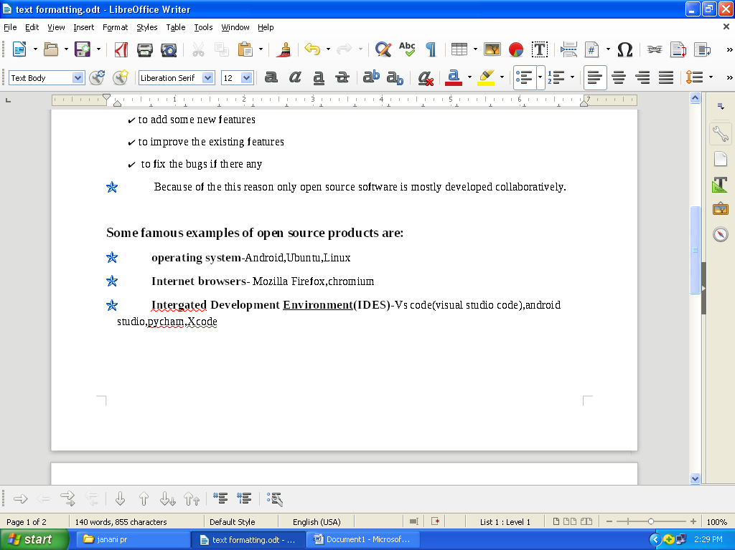

1. **Study and usage of Libre Office Suite – Writer - Covid Vaccination Certificate**

**Aim**

To create a table for COVID vaccination certificate using Libre office writer

**Algorithm**

**Step 1:** Open Libre office writer

**Step 2:** Select writer document and open it

**Step 3:** Click ,Insert , Header and type

This is only a template

**Step 4:** Click, Insert, image, Insert a relevant image and center allign it

**Step 5:** Click, Style, Title,, change the colour of the font and size according to your wish

**Step 6:** Click, Insert, Table and allign Row-6

Column -2 and click, Style, Subtitle and underline it

**Step 7:** Create another table using the same

**Step 8:** Click, Insert, Footer, //footer of image Insert footer image

**Step 9:** Insert watermark, allign size and colour of watermark

**Step 10:** Change it to pdf(exceptional)

**Step 11:** Save the file as Header and footer

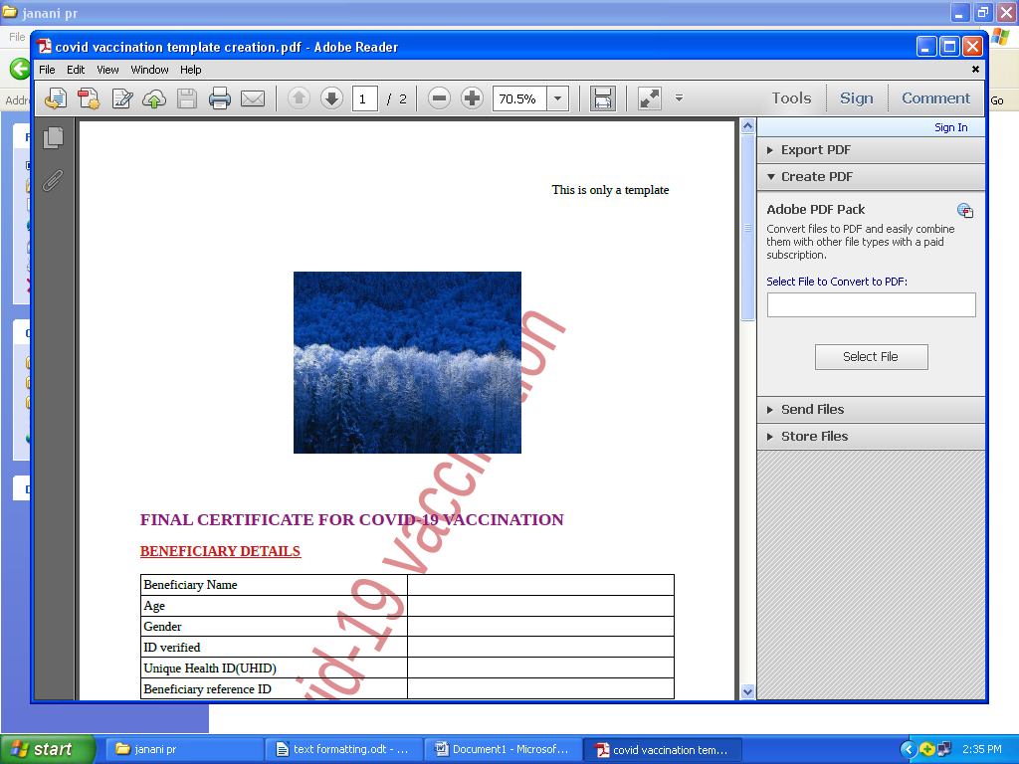**Output:**

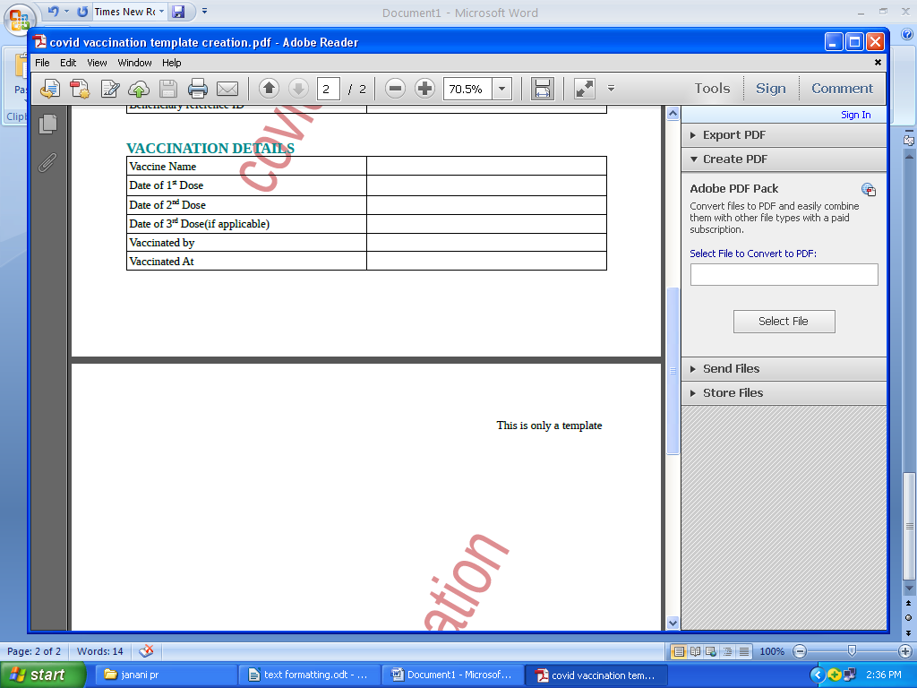

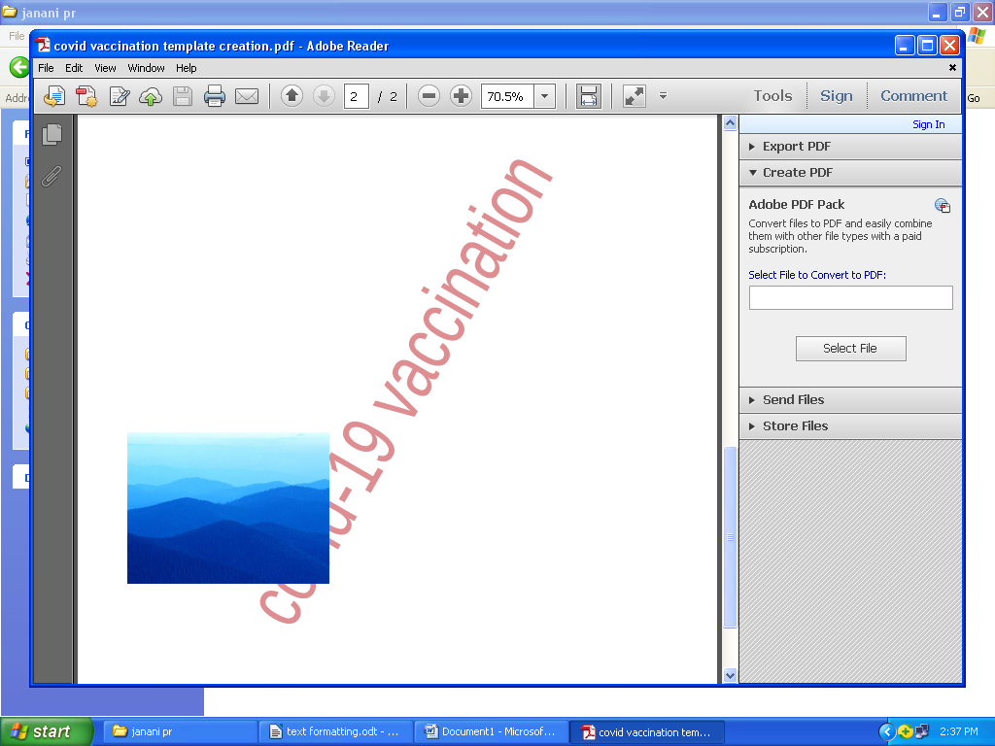

1. **Study and usage of Libre Office Suite – Calc - Chart**

**Aim:**

To create mark analysis for the given data column graph.

|  |  |
| --- | --- |
| SUBJECTS | MARKS |
| EVS | 90 |
| Python | 85 |
| English | 75 |
| java | 98 |
| C++ | 55 |

**Procedure:**

Step 1 : Click and open Libre office calc.

Step 2 : Enter subject and marks in the column.

Step 3 : Select the subject and marks then Click Insert chart option.

Step 4 : Select chart type, shape, select cylinder shape.

Step 5 : Give the x, y axis details.

Step 6 : Go to data range:

1. Click data series in rows.
2. First row as label.
3. First column as label.

Step 7 : Go to data series:

1. Then give, title subtitle
2. Choose the color you want

Step 8 : Click on the chart Insert data labels.

Step 9 : Align the chart size and colors according to your choice.

Step 11: Open addition sheet.

**Output:**

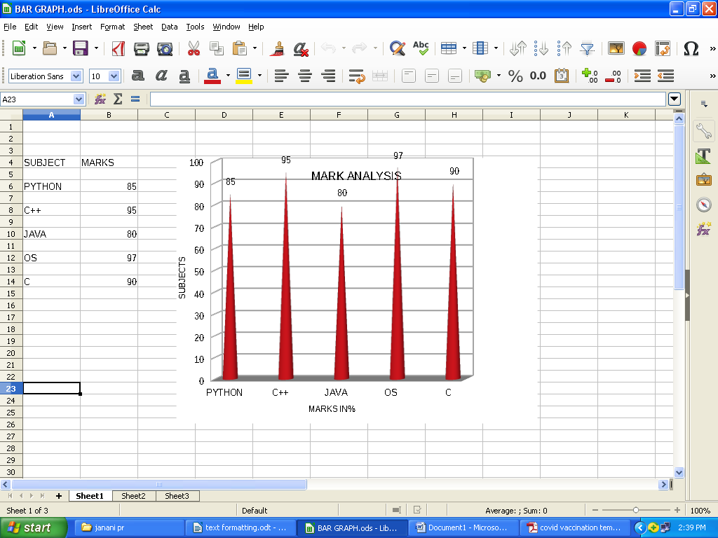

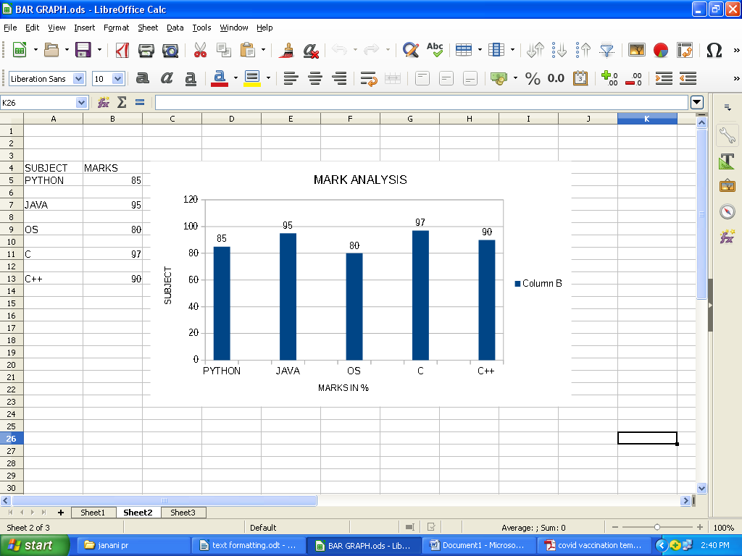

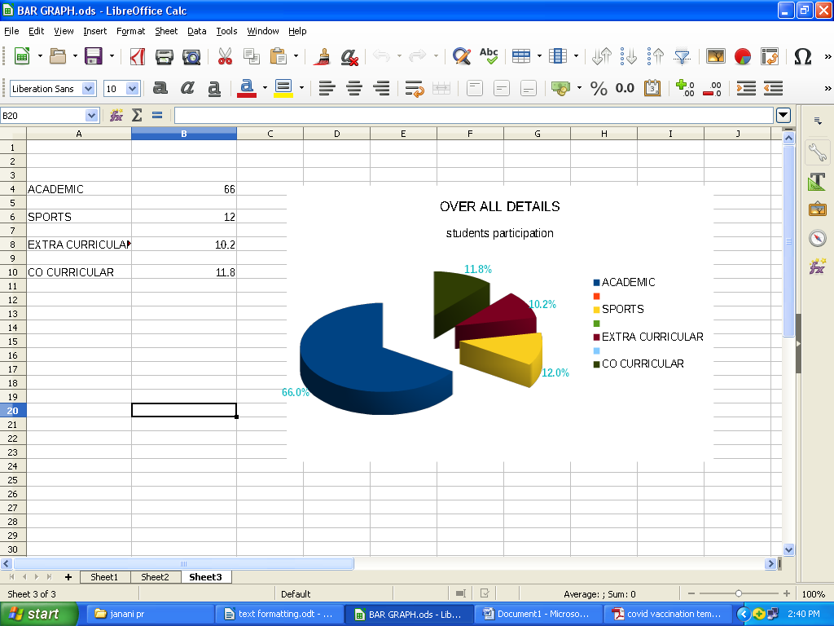

1. **Study and usage of Libre Office Suite – Calc - Filter**

**Aim**

To apply filter in libre office Calc

**Algorithm**

Step 1 : Open Libre office Calc

Step 2 : Enter Students Data like subject and marks in the column.

Step 3 : Select ALL BCA Students who are female

Select Data->Auto Filter Option

Step 4 : Select ALL Male students studying in Section A in any department

Select Data->Auto Filter Option

Step 5: Save the file

**Output**

**Original Data – Before Applying Filter**

|  |  |  |  |  |  |  |  |  |
| --- | --- | --- | --- | --- | --- | --- | --- | --- |
| **Data Sheet** | | | | | | | | |
| **Sl.No.** | **Department** | **Section** | **Gender** | **Semester** | **Mark1** | **Mark2** | **Mark3** | **Average** |
| 1 | BCA | A | F | 1 | 90 | 90 | 67 | 82 |
| 2 | BCA | B | F | 2 | 67 | 78 | 78 | 74 |
| 3 | BBA | C | F | 3 | 78 | 67 | 89 | 78 |
| 4 | BCA | A | M | 4 | 89 | 65 | 87 | 80 |
| 5 | BBA | A | M | 1 | 88 | 64 | 88 | 80 |
| 6 | B.Sc | B | M | 2 | 78 | 56 | 78 | 71 |
| 7 | BBA | B | F | 3 | 76 | 89 | 76 | 80 |
| 8 | BBA | C | F | 4 | 75 | 90 | 94 | 86 |
| 9 | BCA | C | M | 5 | 89 | 94 | 97 | 93 |
| 10 | BCA | A | M | 5 | 90 | 97 | 96 | 94 |
| 11 | B.Sc | A | F | 6 | 94 | 96 | 88 | 93 |
| 12 | B.Sc | A | M | 6 | 97 | 88 | 97 | 94 |
| 13 | B.Sc | B | F | 1 | 96 | 78 | 96 | 90 |
| 14 | B.Sc | B | M | 2 | 87 | 76 | 87 | 83 |
| 15 | BCA | B | F | 3 | 78 | 78 | 78 | 78 |
| 16 | BBA | C | F | 4 | 67 | 89 | 65 | 74 |
| 17 | BCA | C | M | 5 | 65 | 87 | 78 | 77 |
| 18 | BBA | C | M | 6 | 64 | 86 | 89 | 80 |
| 19 | BCA | A | F | 5 | 56 | 85 | 67 | 69 |
| 20 | BCA | B | F | 6 | 89 | 88 | 78 | 85 |

1. **Select ALL BCA Students who are female**

**Select Data->Auto Filter Option**

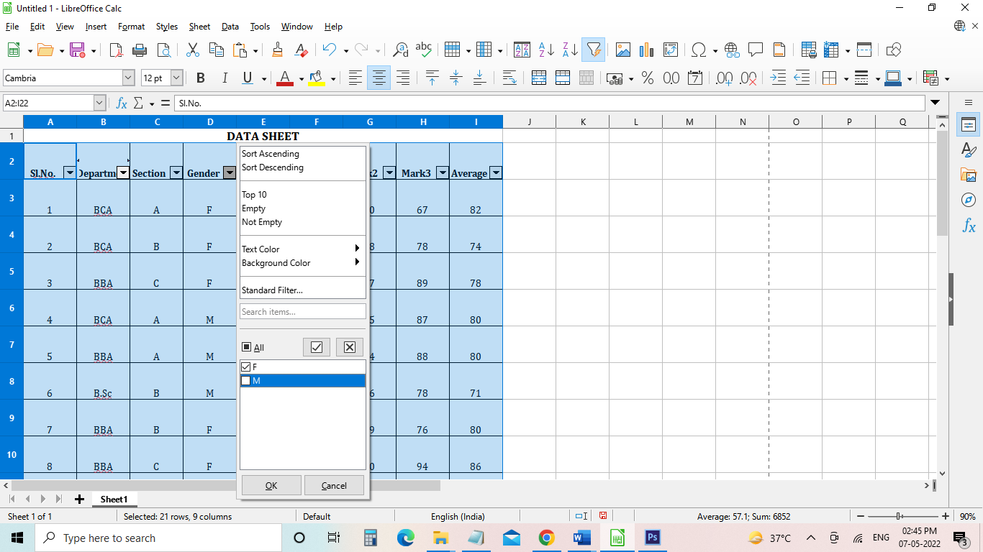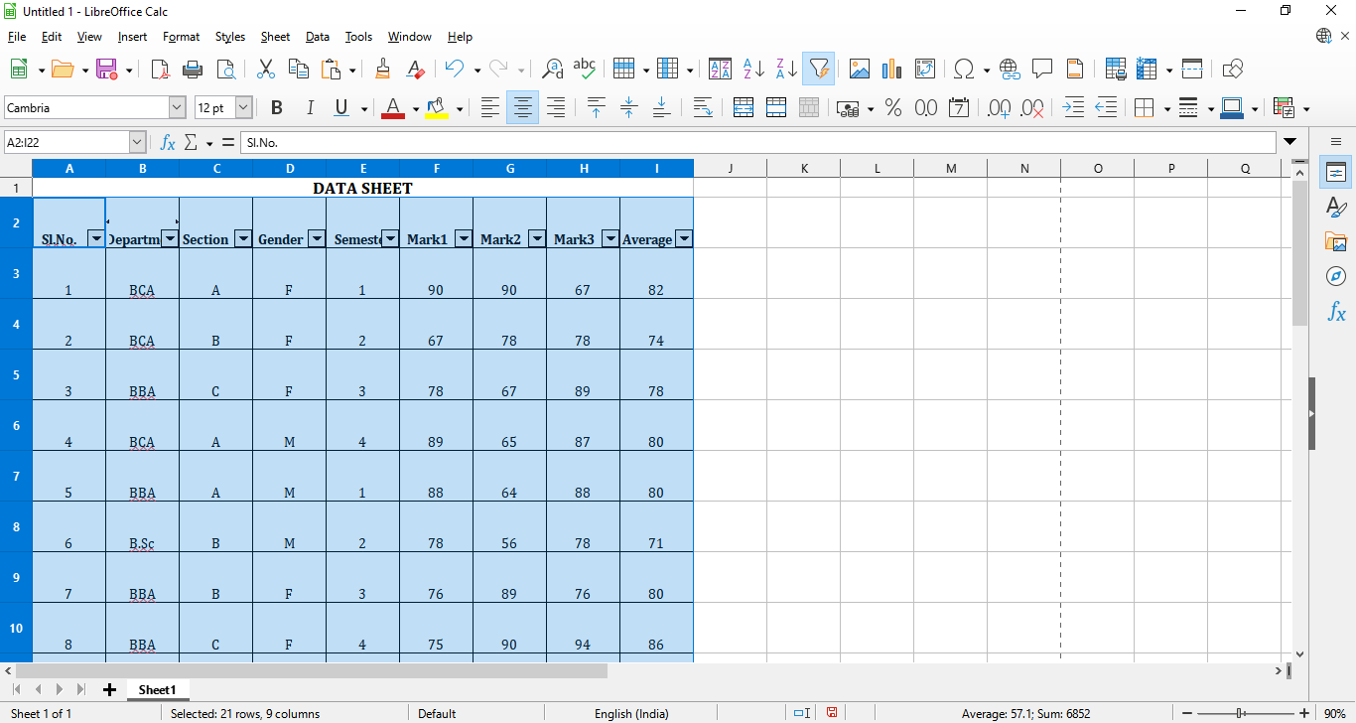

|  |  |  |  |  |  |  |  |  |
| --- | --- | --- | --- | --- | --- | --- | --- | --- |
| **Result**  **DATA SHEET** | | | | | | | | |
| **Sl.No.** | **Department** | **Section** | **Gender** | **Semester** | **Mark1** | **Mark2** | **Mark3** | **Average** |
| 1 | BCA | A | F | 1 | 90 | 90 | 67 | 82 |
| 2 | BCA | B | F | 2 | 67 | 78 | 78 | 74 |
| 15 | BCA | B | F | 3 | 78 | 78 | 78 | 78 |
| 19 | BCA | A | F | 5 | 56 | 85 | 67 | 69 |
| 20 | BCA | B | F | 6 | 89 | 88 | 78 | 85 |

1. **Select ALL Male students studying in Section A in any department**

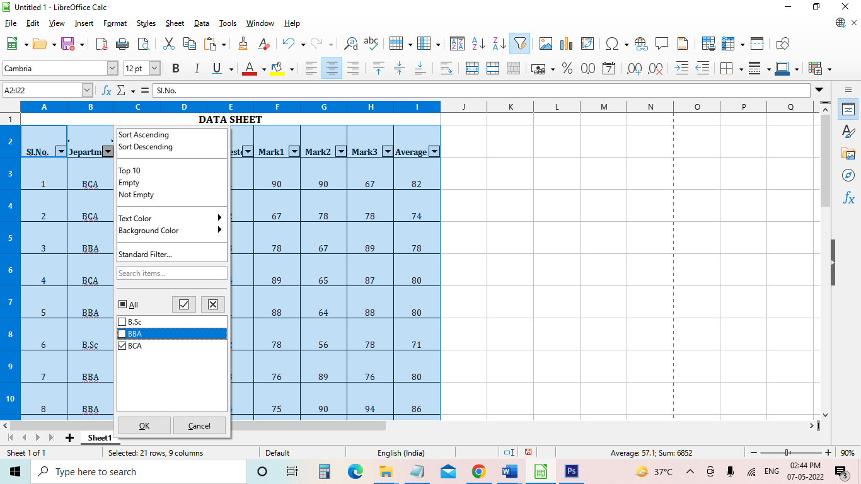**Select Data->Auto Filter Option**

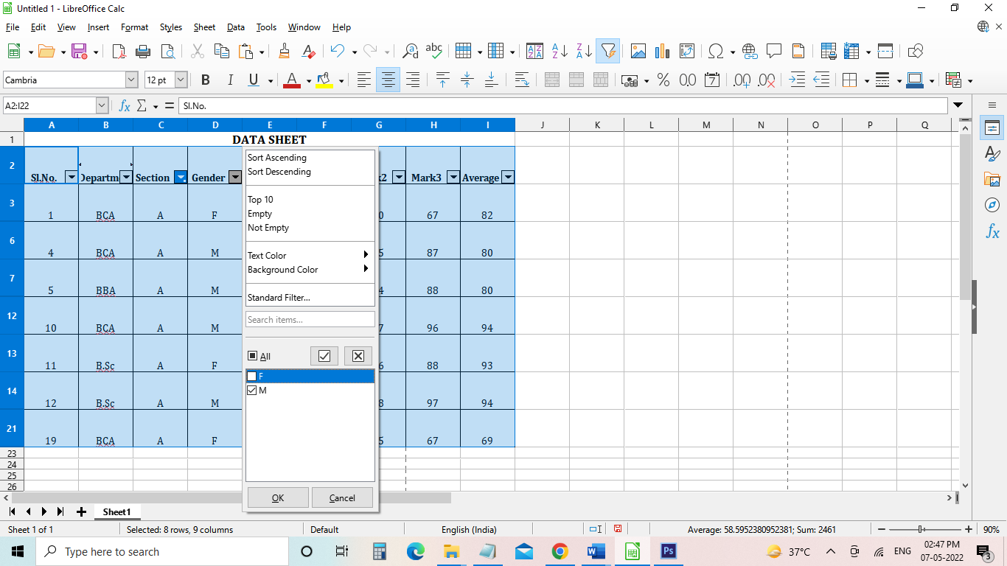

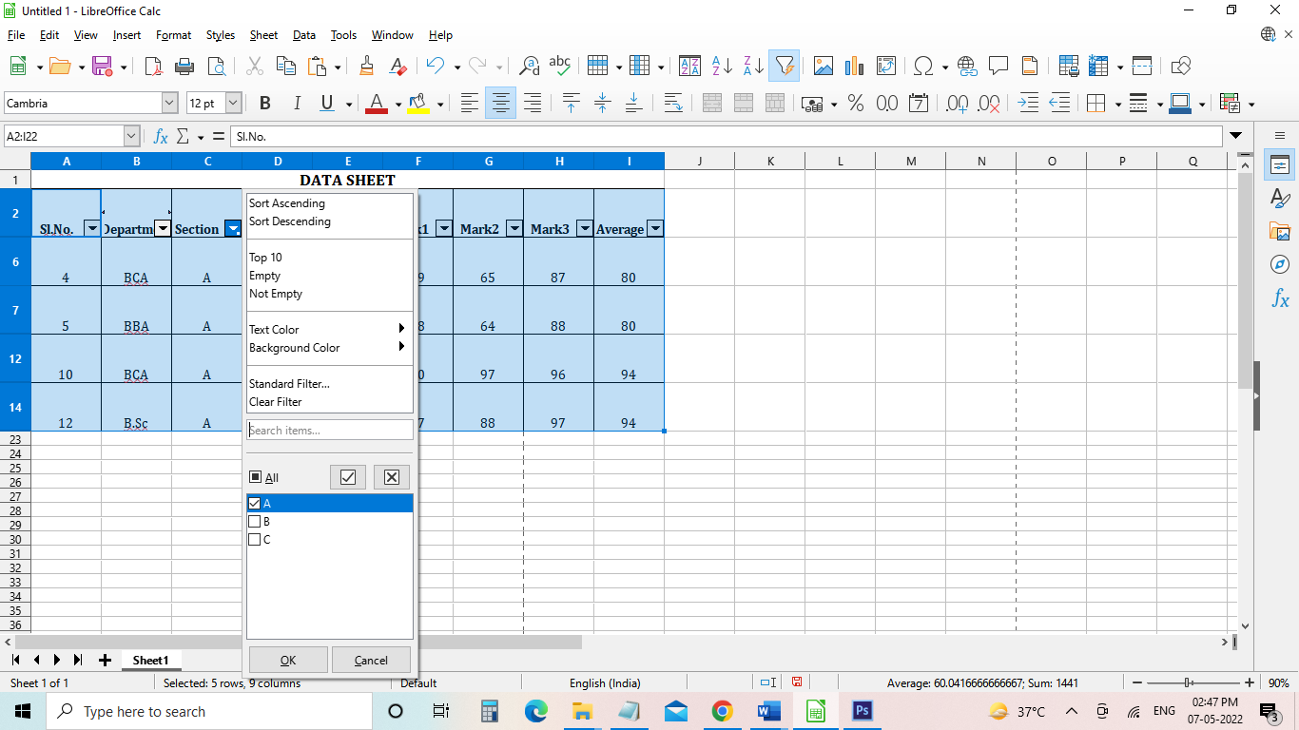

**Result**

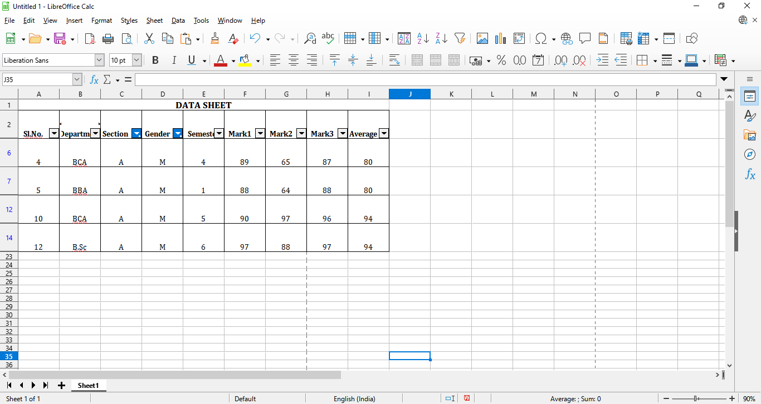

1. **Select All students from of BCA department whose 1st semester average mark is greater than 90**

**Select ->More Filters->Standard Filters**

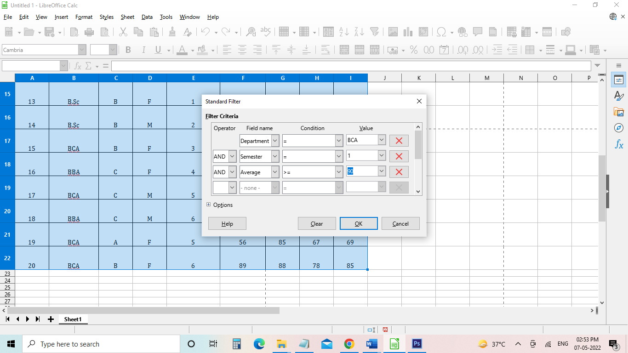

**Result:**

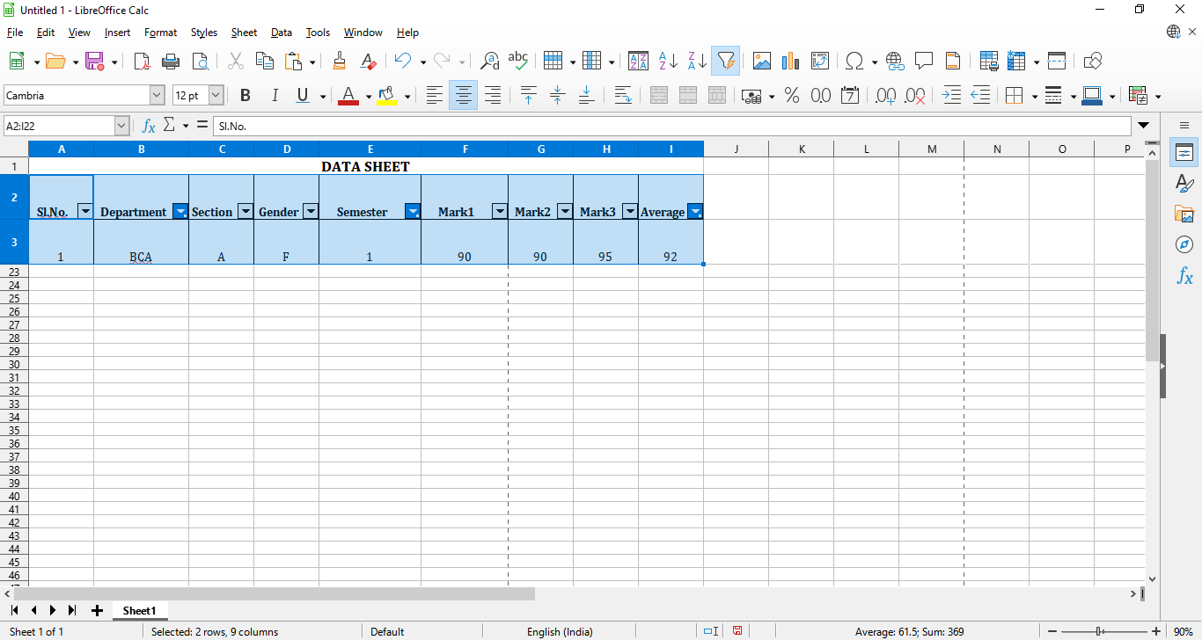

1. **Select all female students belonging to BBA students with average score between 60 and 90. Extract the result in new cell**

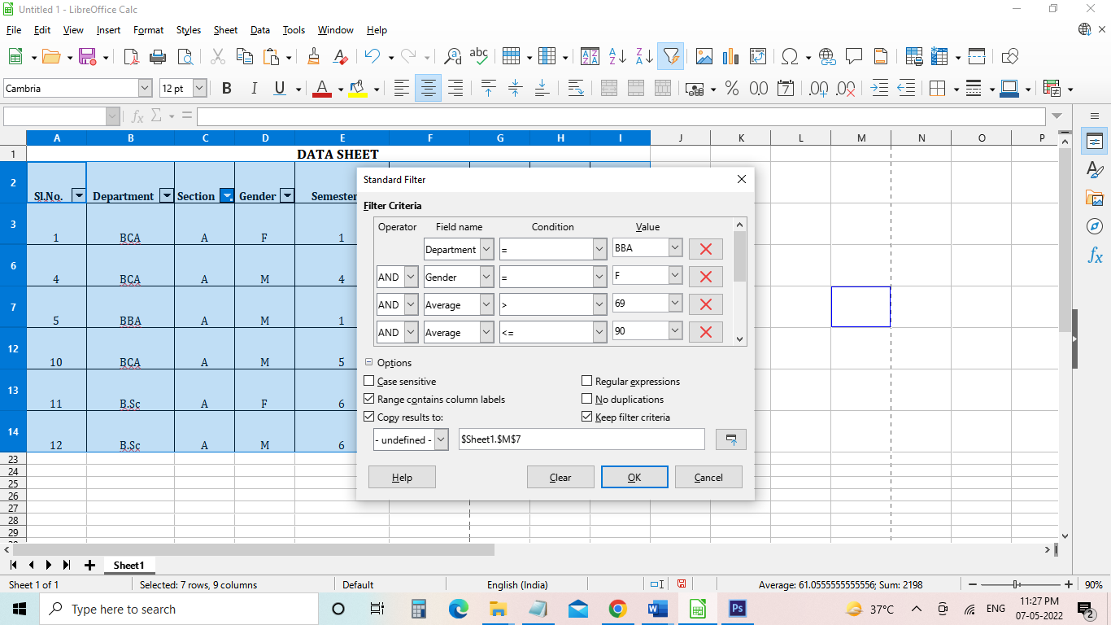

**Result:**

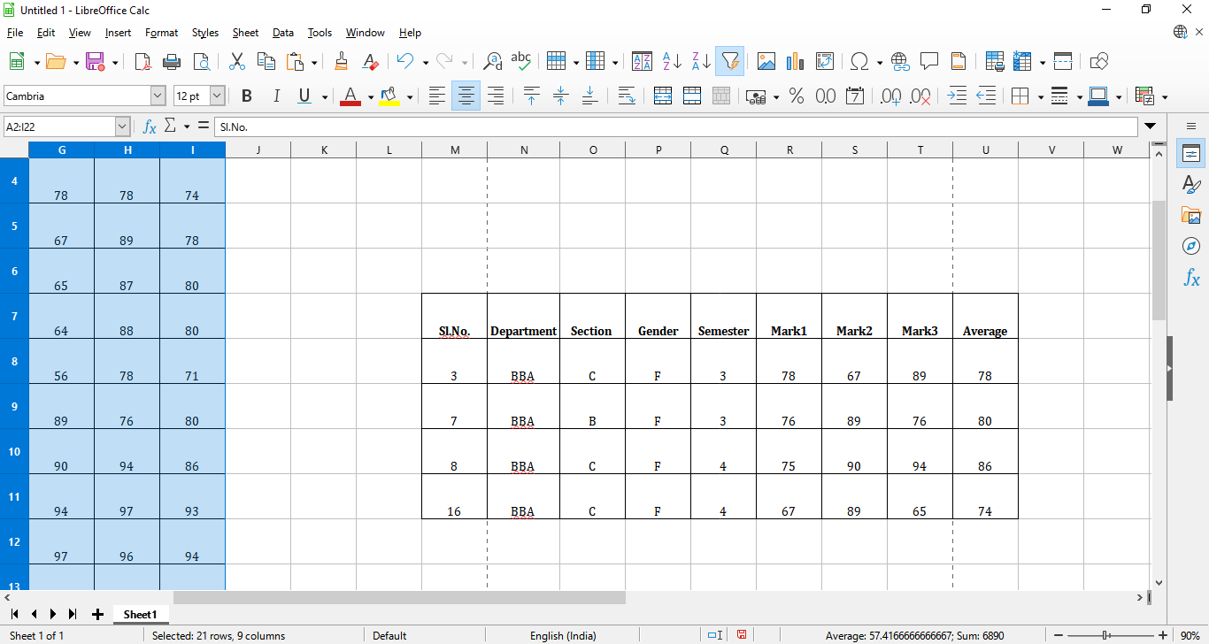

1. **Select all BCA students whose 5 and 6 semester marks is greater than 75**

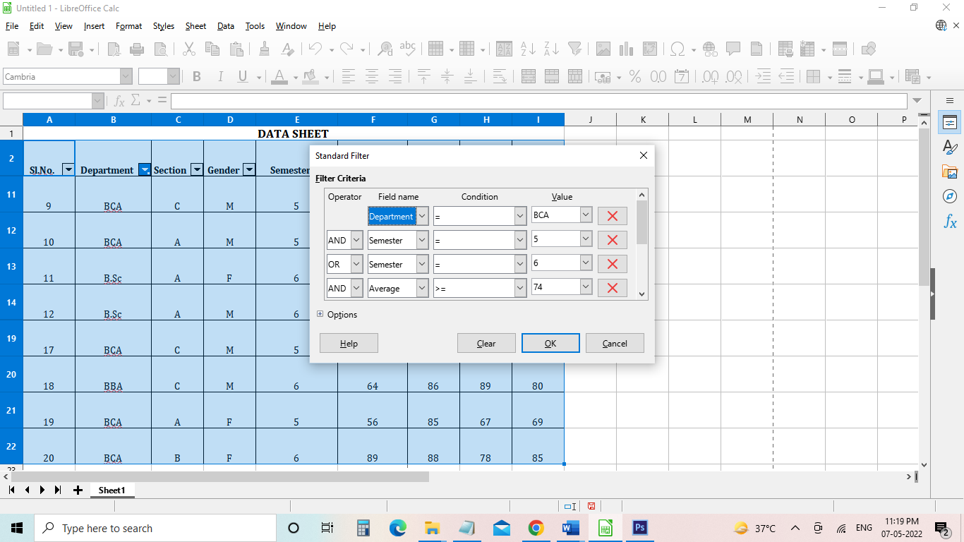

**Result:**

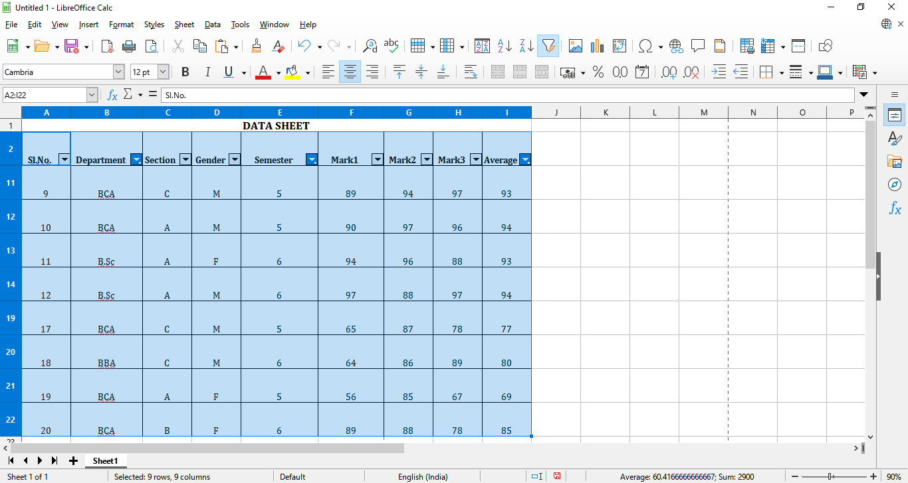

1. **Select A section students across all departments whose average is greater than 70**

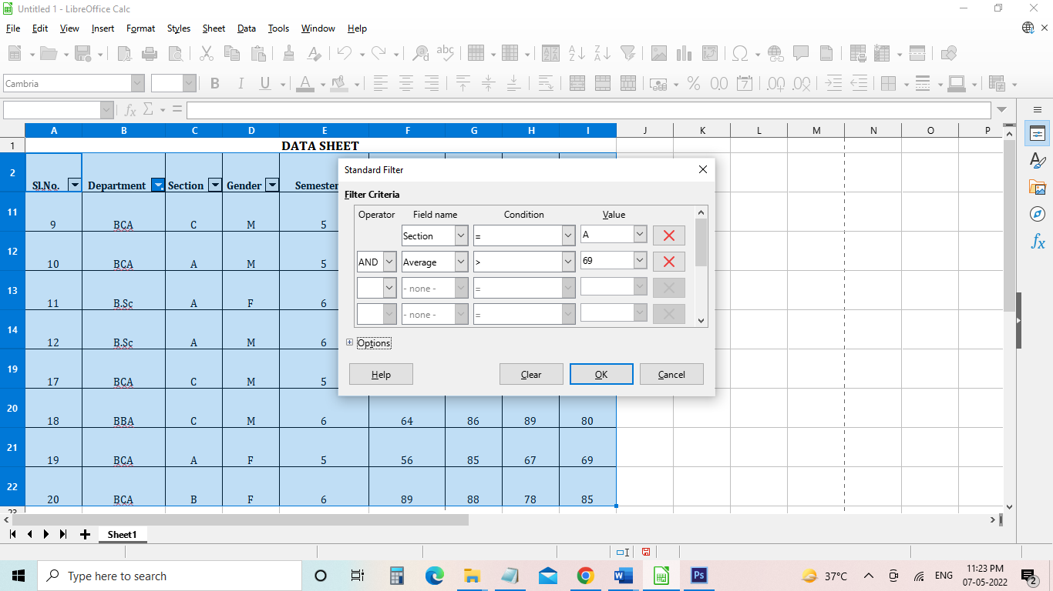

**Result:**

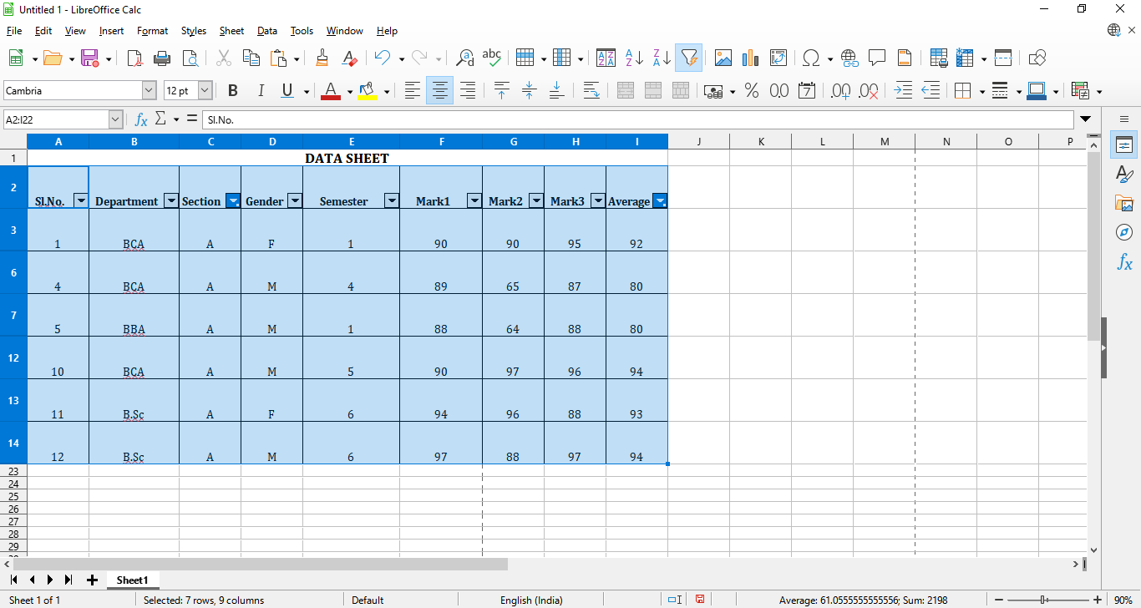

1. **Study and usage of Libre Office Suite – Impress - Presentation**

**Aim**

To create the presentation in Libre office Impress

**Algorithm**

Step 1: open libre office Impress

Stept 2 : Select the templates

Step3 : Fix the font size for heading and the content

Step 4 : create the slides

Stept 5: Check with slide show

Step 6 : Save the file

**Output**

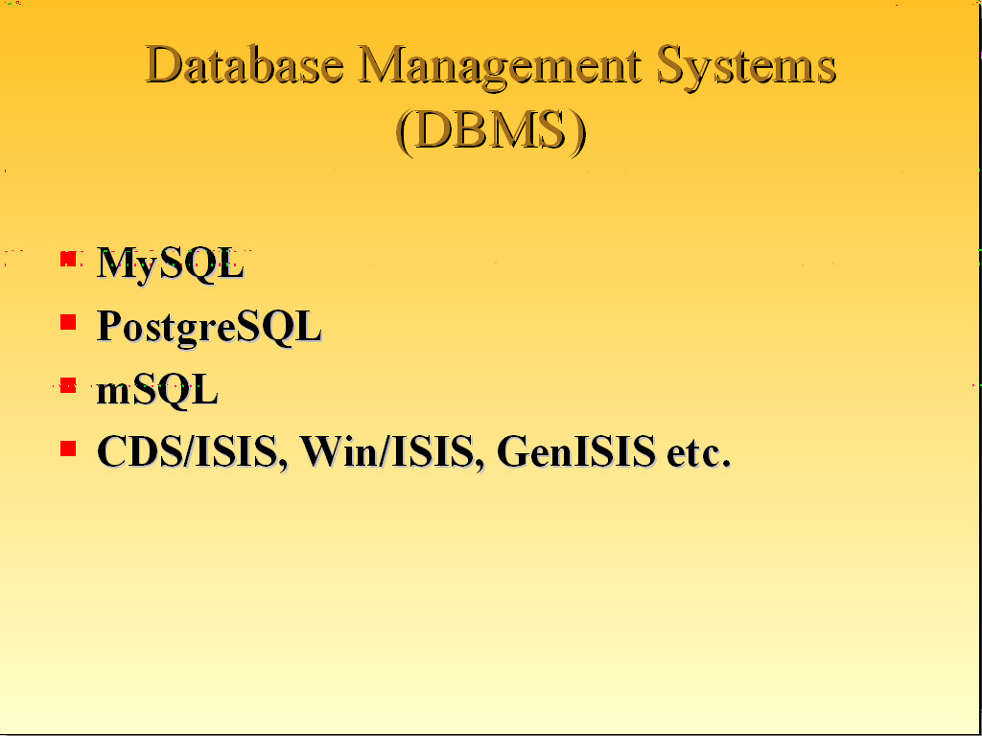

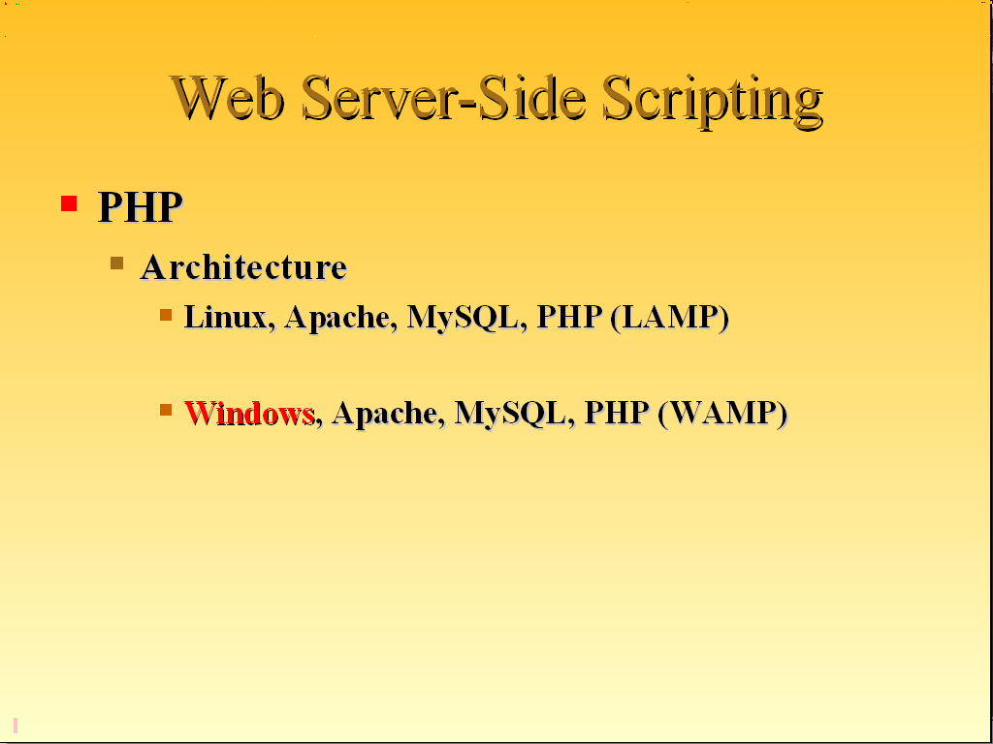

1. **Study and usage of Libre Office Suite – Impress - Animation**

**Aim**

To create the presentation with animation in libre office Impress

**Algorithm**

Step 1: open libre office Impress

Stept 2 : Select the templates

Step3 : Fix the font size for heading and the content

Stept 4: Create the slides with content

Step 5 : select animation tab

Step 6 : select the content to be animated and select the animation type

Step 7 : Check the preview of the animation

Step 6 : Save the file

**Output**



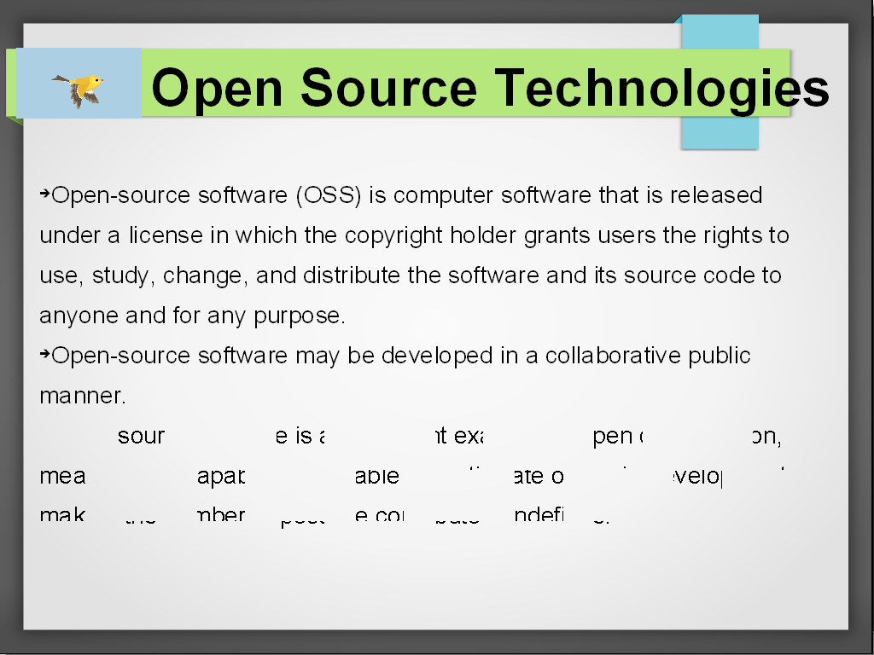

1. **Simple Applications using Python – Python to Excel**

**Aim**

To move the data from python to excel

**Algorithm**

1. import the package xlwt

2. Open the work book

3. Add the sheet

4. Get the data

5. Write the data into the sheet

6. Save the file

**Coding**

import xlwt

wb=xlwt.Workbook()

ws=wb.add_sheet("Data")

i=1

r=0

while i<=4:

regno=int(input("Enter the Regno Number:"))

name=input("Enter the Name:")

sub=input("Enter the Subject:")

mark=float(input("Enter the Mark:"))

ws.write(r,0,regno)

ws.write(r,1,name)

ws.write(r,2,"BCA")

ws.write(r,3,sub)

ws.write(r,4,mark)

r=r+1

i=i+1

wb.save("BCA.xls")

**Output**

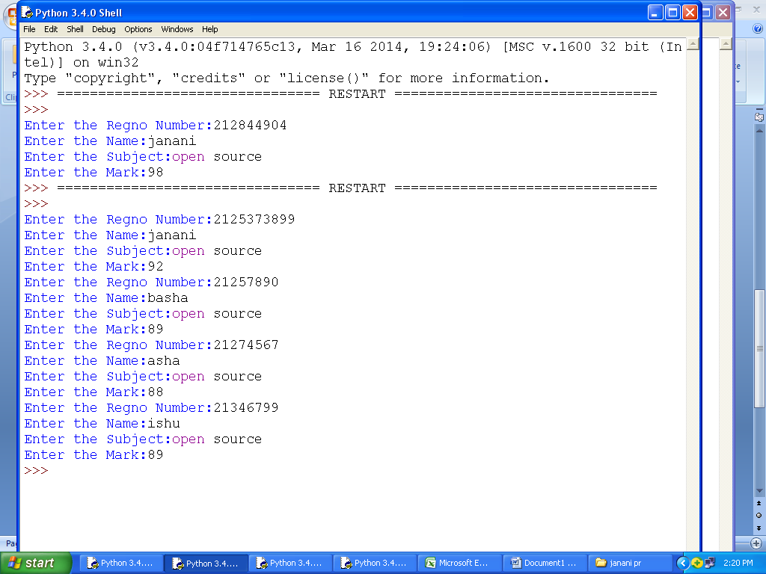

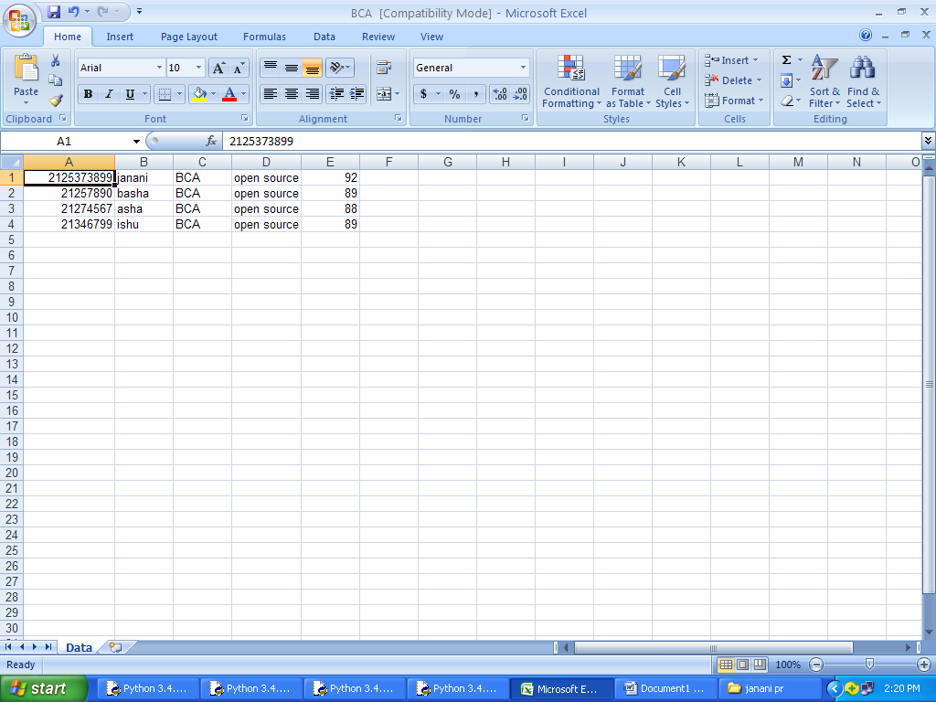

1. **Simple Applications using Python – Data Visualization**

**Aim**

To visualize the data using python matplotlib

**Algorithm**

1. Import matplotlib
2. Set the x axis and axis values
3. Create the pie chart
4. Save the file

**Coding**

import matplotlib.pyplot as p

xvalues=["Academic","sports","Co-Curricular","Extra-Curricular"]

yvalues=[70.7,15.3,9.4,4.6]

p.pie(yvalues,colors=['cyan','yellow','green','r'],labels=xvalues,

shadow=True,explode=(0,0,0.1,0),autopct="%0.2F%%",radius=1.3)

p.title("Percentage of Participation")

p.show()

**Output**

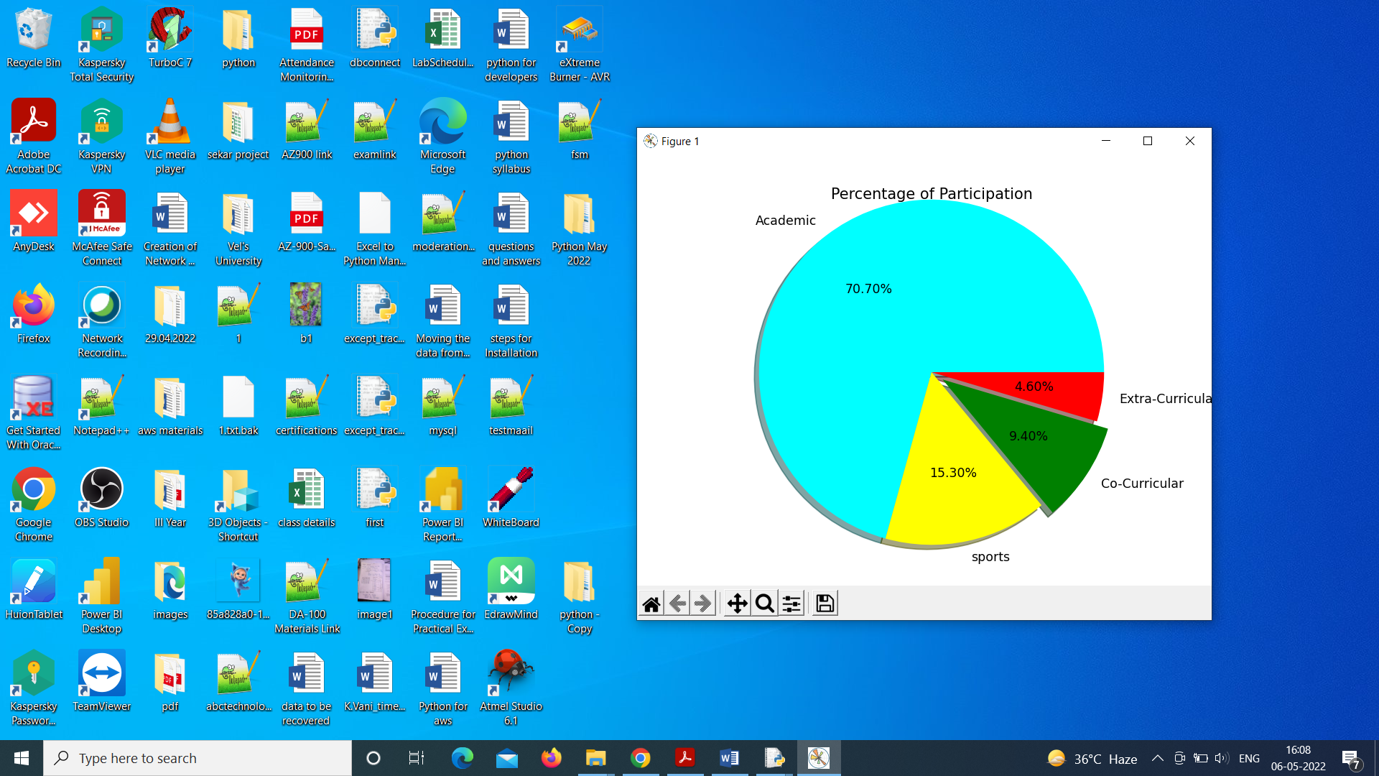

1. **Creation of Network Diagrams using GraphViz – Finite State Machine**

**Aim**

To create Finite state machine using graphviz

**Algorithm**

1. Import graphviz
2. Using attr set the nodes
3. Draw the nodes and edges
4. Save the file

**Coding**

import graphviz

f=graphviz.Digraph('finite_state_machine', filename='sample.gv')

# Creating starting and Ending Nodes

f.attr(rankdir='LR', size='8,5')

f.attr('node', shape='doublecircle')

f.node('LR_0')

f.node('LR_3')

f.node('LR_4')

f.node('LR_8')

# Creating intermediate nodes

f.attr('node', shape='circle')

f.edge('LR_0', 'LR_2', label='12')

f.edge('LR_0', 'LR_1', label='8')

f.edge('LR_1', 'LR_3', label='10')

f.edge('LR_2', 'LR_6', label='6')

f.edge('LR_6', 'LR_6', label='2')

f.edge('LR_2', 'LR_4', label='4')

f.edge('LR_2', 'LR_5', label='9')

f.edge('LR_5', 'LR_7', label='15')

f.edge('LR_7', 'LR_8', label='20')

f.edge('LR_2', 'LR_6', label='6')

f.edge('LR_8', 'LR_7', label='20')

f.view()

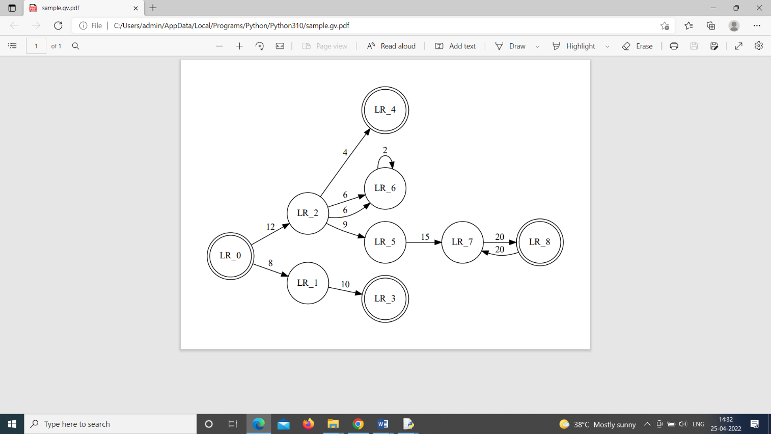**Output**

1. **Creation of Network Diagrams using GraphViz – BTree**

**Aim**

To create B-Tree using graphviz

**Algorithm**

1. import graphviz
2. from graphviz import nohtml
3. draw the nodes and edges
4. Save the file

**Coding**

import graphviz

from graphviz import nohtml

g=graphviz.Digraph('g',filename="binarytree.gv",

node_attr={'shape':'record',

'heigtht':'.1'})

g.node('node0',nohtml('<f0>|<f1>G|<f2>'))

g.node('node1',nohtml('<f0>|<f1>E|<f2>'))

g.node('node2',nohtml('<f0>|<f1>R|<f2>'))

g.node('node3',nohtml('<f0>|<f1>B|<f2>'))

g.node('node4',nohtml('<f0>|<f1>F|<f2>'))

g.node('node5',nohtml('<f0>|<f1>H|<f2>'))

g.node('node6',nohtml('<f0>|<f1>Y|<f2>'))

g.edge('node0:f0','node1:f1')

g.edge('node0:f2','node2:f1')

g.edge('node1:f0','node3:f1')

g.edge('node1:f2','node4:f1')

g.edge('node2:f0','node5:f1')

g.edge('node2:f2','node6:f1')

g.view()

**Output**

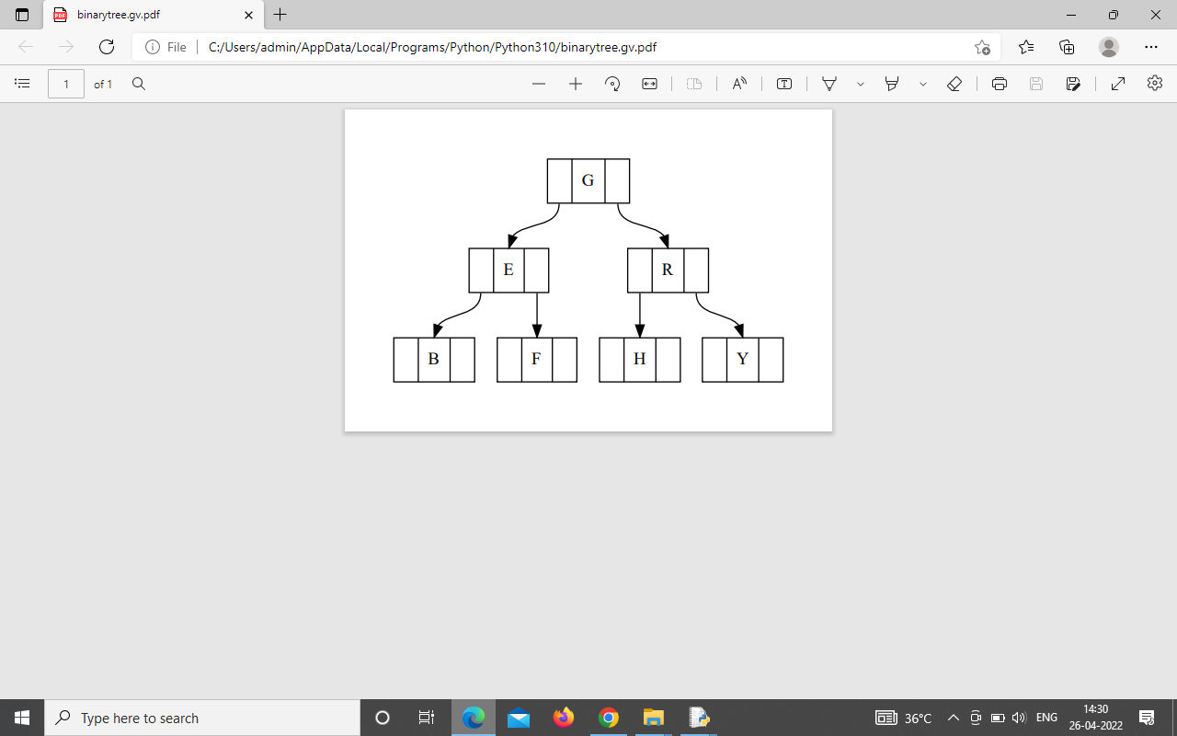

1. **Simple Application Using PHP**

**Aim**

To create simple PHP Program

**Algorithm**

1. Create the html coding
2. Create the php coding inside the html
3. Prin the content using echo statement
4. Save the file
5. Switch on the WAMP Server
6. Open local host
7. Open the file which contains the php coding

**Coding**

<html>

<head><title>PHP PROGRAMMING</CENTER>

</TITLE>

<h1> Php Programming</h1>

</HEAD>

<body>

<?php

# the dot operator is the concatenation operator

/* multiple

comment

line*/

//this is also a comment line

echo "Welcome to the world of PhP programming"."<br>";

$name = "Priya";

$age=18;

echo "My name is ".$name." I am ".$age." years old<br>";

echo "I love php";

?>

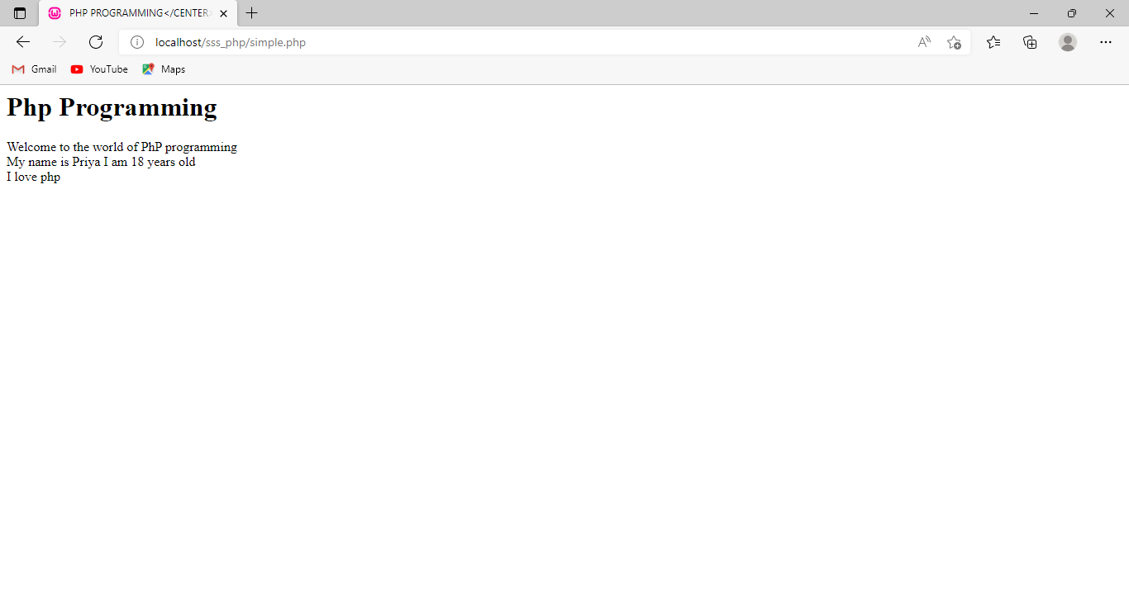**Output**

1. **Simple Application Using PHP – Organ Donation Card Generation**

**Aim**

To create Organ Donation card creation in PHP

**Algorithm**

1. Create the html coding
2. Design the form using form tag
3. Create the php coding inside the html
4. Prin the content using echo statement
5. Save the file
6. Switch on the WAMP Server
7. Open local host
8. Open the file which contains the php coding

**Coding**

**HTML FILE**

<html>

<form name="form1" action="form2.php" method="post">

<b>My Personal Details:<br></b>

First Name

<input type="text" name="txtname" >

<br>

Blood Group

<input type = "text" name="txtbg">

<br>

Organs I wish to donate upon my death

<input type = "text" name="txtorgans">

<br>

My Mobile

<input type="text" name="txtMobile"/>

<br>

<input type="submit" name="btnSubmit" value="Submit"/>

</form>

</body>

</html>

**PHP FILE(form2.php)**

<?php

$fn=$_POST["txtname"];

$bg=$_POST["txtbg"];

$organ=$_POST["txtorgans"];

$mob=$_POST["txtMobile"];

echo("Organ Donation Card <br>

First Name:".$fn.

"<br>Blood Group".$bg.

"<br>Organs I wish to donate upon my death".$organ.

"<br>My Mobile".$mob);

?>

**Output**

**HTML PAGE**

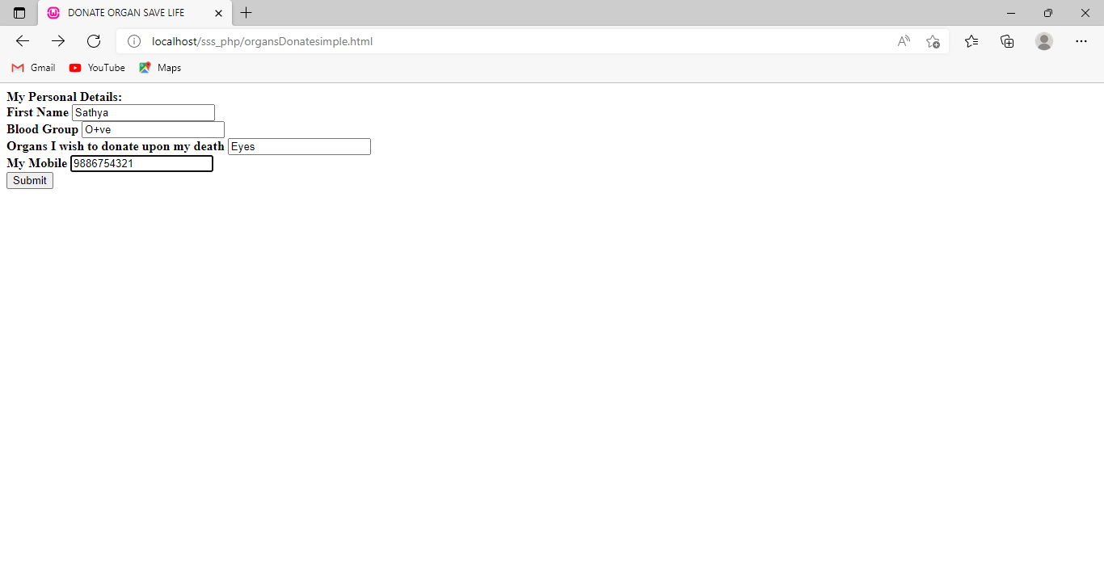

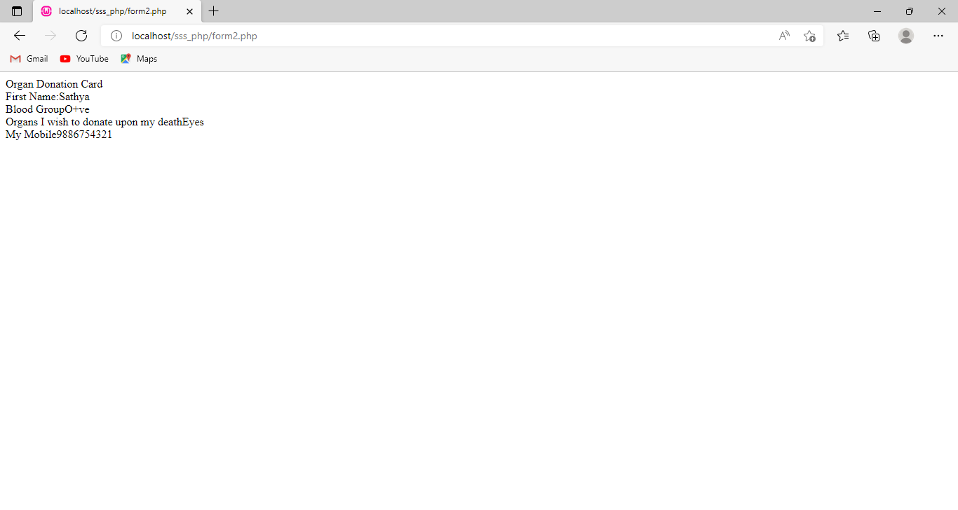**PHP PAGE**

1. **Text Processing with PERL – Simple Perl Program**

**Aim**

To create simple perl program

**Algorithm**

1. Open notepad
2. Declare the variable in perl
3. Print the content
4. Save the file with.pl extension
5. Open command prompt
6. Run the file as follows

perl filename.pl

**Coding**

print "Hello!!! II BCA Welcome to Perl world";

$name ='BCA';

($age,$street)=("II Year","Shri shankalal Sundarbai Shasun Jain College for Women");

$myinfo="\n $name of $age Studies on \"$street\"";

print $myinfo;

**Output**

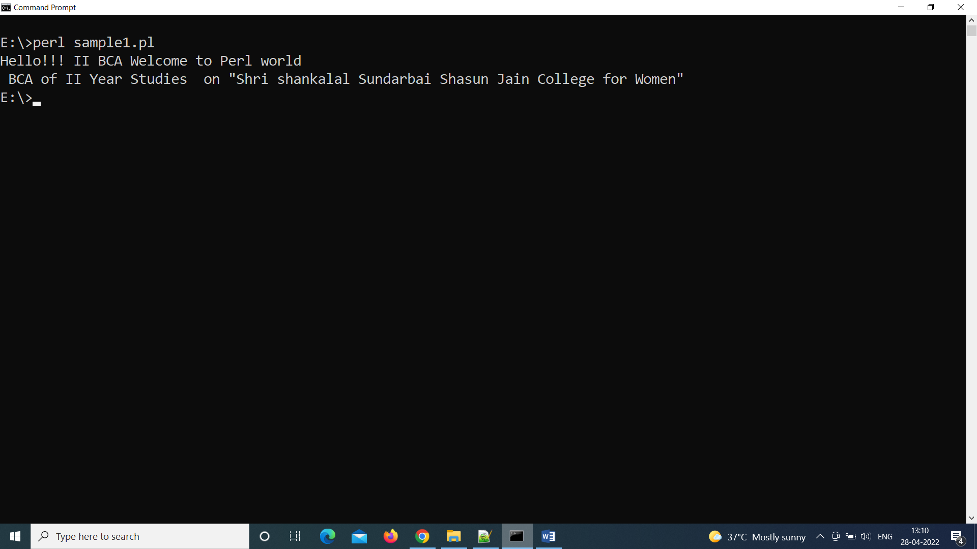

1. **Text Processing with PERL – Random Number Generation**

**Aim**

To create random numbers in perl

**Algorithm**

1. Open notepad
2. Create the function to generate the random numbers
3. Using get_random() generate the random numbers
4. Save the file with.pl extension
5. Open command prompt
6. Run the file as follows

perl filename.pl

**Coding**

use feature 'say';

sub get_random

{

return int (rand 11);

}

my @a = (1..9);

for $i (@a)

{

say "Random Number :",get_random();

}

**Output**

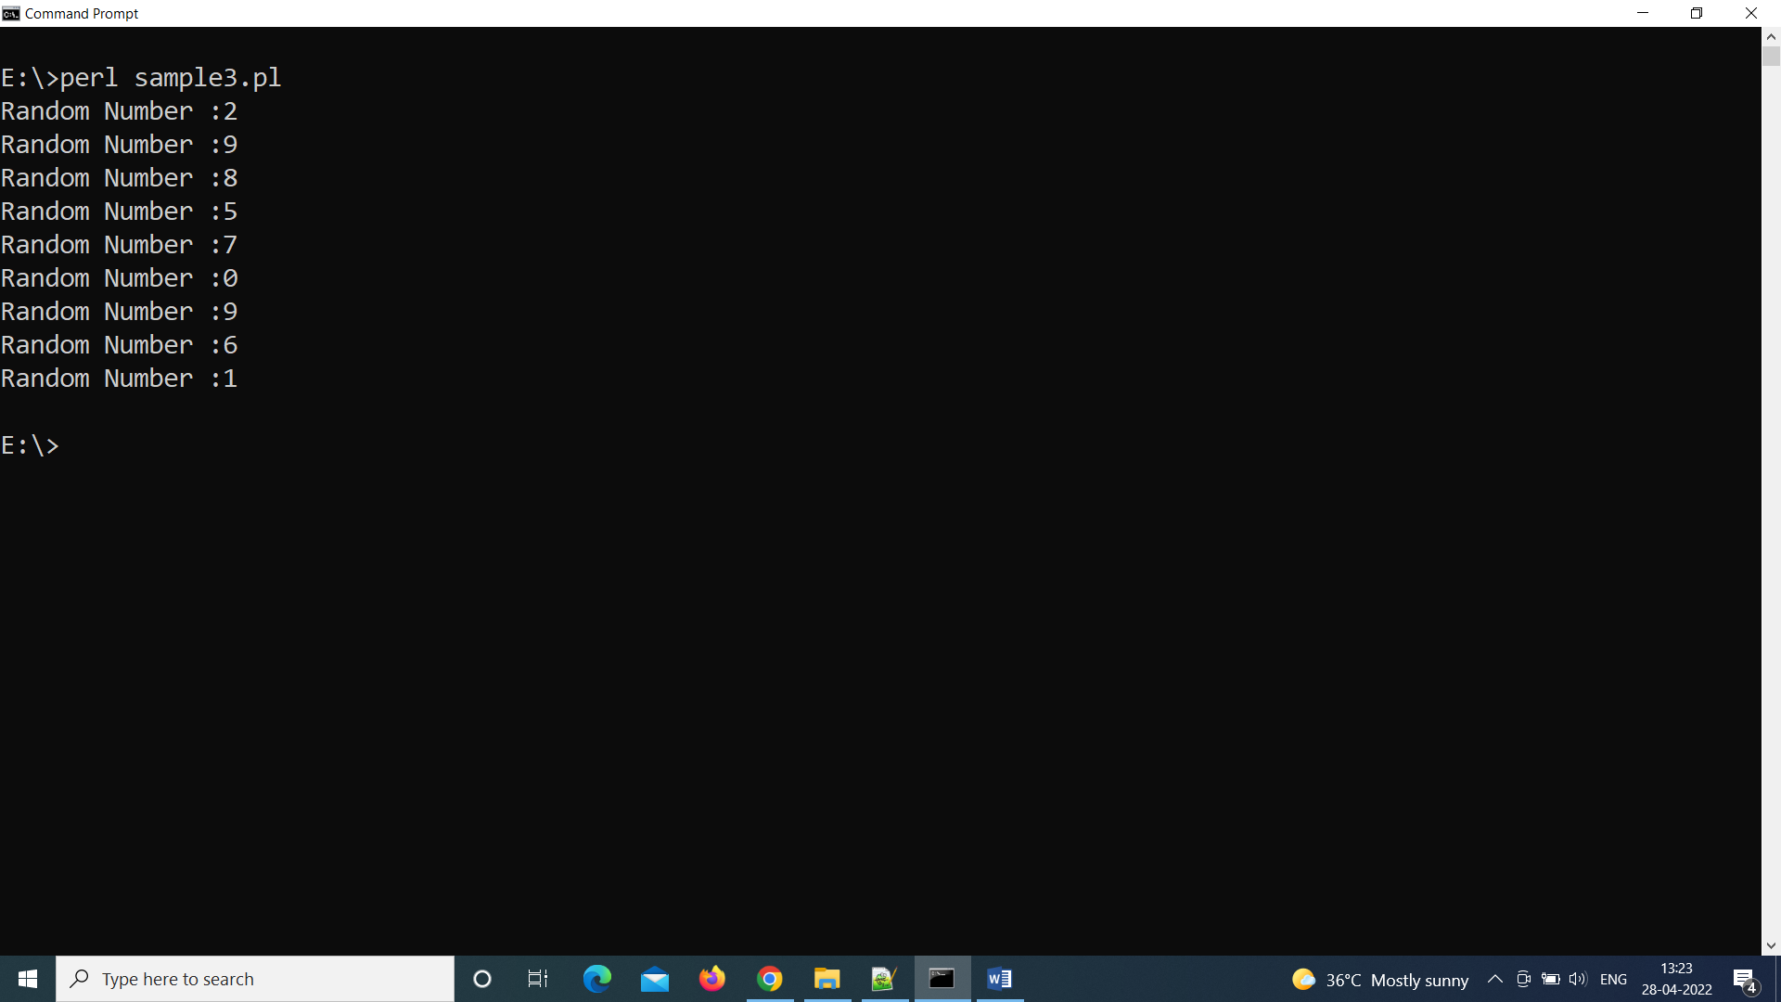

1. **Text Processing with PERL – File Writing**

**Aim**

To write the content in Perl

**Algorithm**

1. Open notepad
2. Open the text file for writing
3. Using print statement write the content to the file
4. Close the text file
5. Save the file
6. Open command prompt
7. Run the file as follows

perl filename.pl

**Coding**

$filename = 'file1.txt';

open(FH, '>', $filename) or die "Could not open file '$filename' $!";

print FH "Hello!! We have created this file as an example\n";

print FH "II BCA is working on Perl Program \n";

print FH "Interesting to learn Perl\n";

print FH "Thank u\n\n";

close FH;

print "done\n";

**Output**

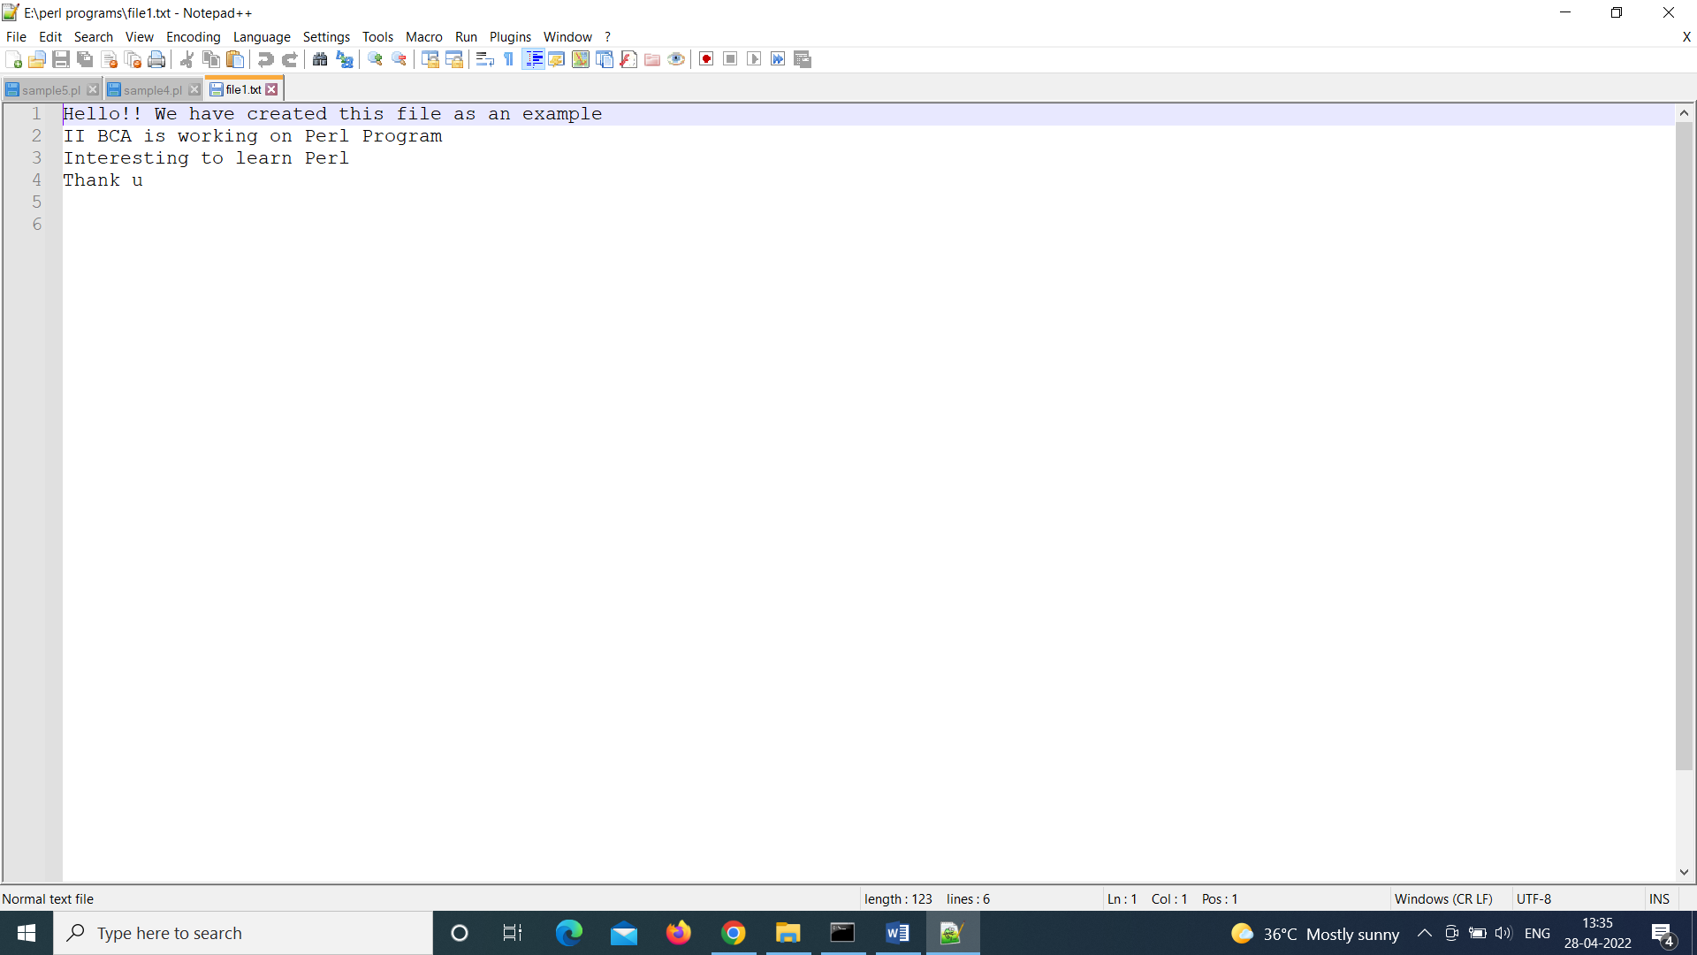

1. **Text Processing with PERL – Regular Expression**

**Aim**

To implement regular expression in perl

**Algorithm**

1. Open notepad
2. Open the text file for reading
3. Read the line and check the pattern
4. Print the matched lines
5. Close the text file
6. Save the file
7. Open command prompt
8. Run the file as follows

perl filename.pl

**Concepts**

* Perl provides several numbers of regular expression quantifiers which are used to specify how many times a given character can be repeated before matching is done.
* This is mainly used when the number of characters going to be matched is unknown.
* **There are six types of Perl quantifiers which are given below:**
  + = This says the component must be present either zero or more times.
    - Va=ni
      * Vni
  + **+** = This says the component must be present either one or more times.ii
    - **Va+ni**
      * **Vani**
      * Vaani
      * Vaaaaaani
      * Vni
  + **?** = This says the component must be present either zero or one time.
    - **.**docx?
    - **.**xlsx?
  + **{n}** = This says the component must be present n times.
    - **Va{5}ni**
  + **{n, }** = This says the component must be present at least n times.
    - **V{6,}**
  + **{n, m}** = This says the component must be present at least n times and no more than m times.
    - **Va{2,5}ni**

**Coding**

use strict;

use warnings;

sub main

{

my $file = 'mailid.txt';

open(FH, $file) or die("File $file not found");

while(my $String = <FH>)

{

if($String =~ /the/)

{

print "$String \n";

}

}

close(FH);

}

main();

**Output**

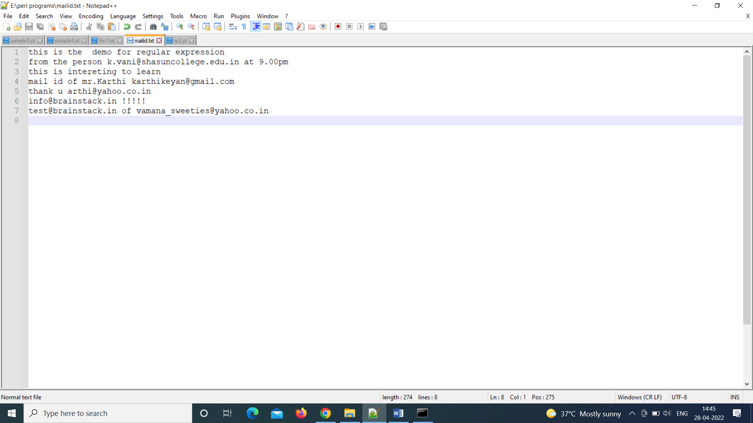

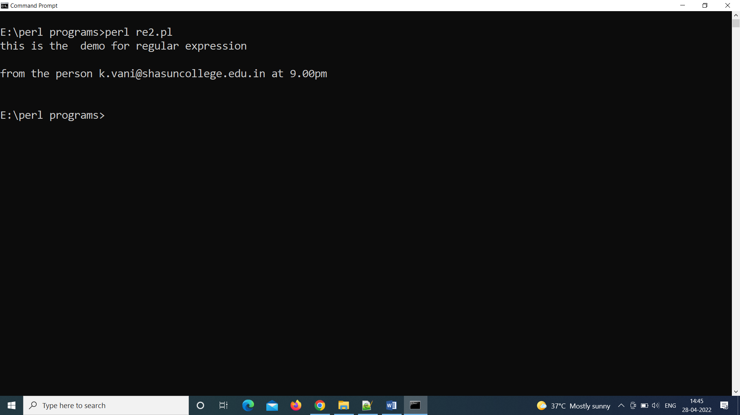

1. **Image Editing Using GIMP - Birthday Invite Creation Using Basic Tools**

**Aim**

To create the birthday invitation

**Algorithm**

**Steps**

1. Create a new file with 600*900 (W*H) as dimension and name it as invite
2. Open an appropriate image to set it as the background
3. Select the image(Ctrl+A) and paste it as the background in the invite file
4. Choose the text tool and type the content of the invitation
5. Use the move tool to move the text to the desired position
6. Change the color, size and font style of the given text
7. Save the file
8. Use the export option in File menu to export to the desired picture format (jpg/png)

**Output**

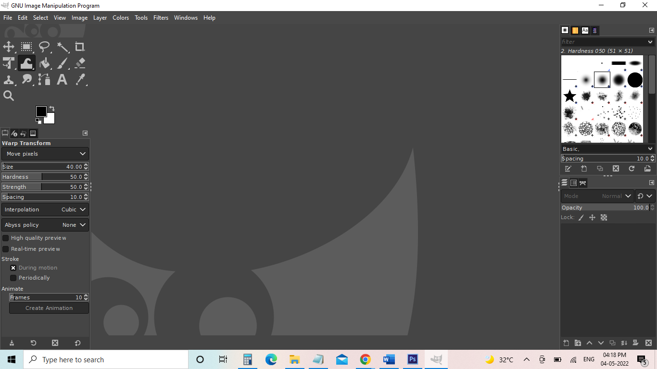



1. **Image Editing Using GIMP - Color Replacement**

**Aim**

To change the color of the image

**Algorithm**

**Steps**

1. Open the image
2. Choose the fuzzy select tool and choose the area where the color needs to be replaced
3. After selecting the area, add a new layer and set the ‘Fill with” option to “transparency”
4. Now set the mode of the newly added layer to “Overlay”
5. Choose the paint brush tool or bucket tool and choose the desired color
6. Fill the selection
7. Now the selected area’s original color will be replaced with the new color

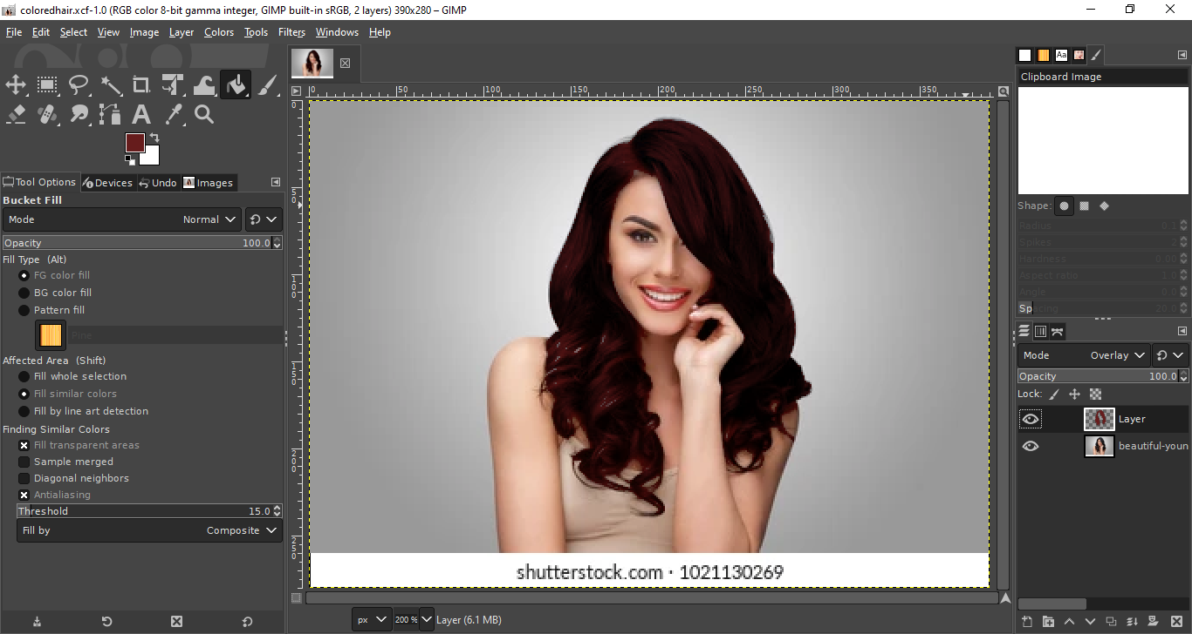

**Before**



**After color replacement**



1. **Linux Installation**

**Aim**

To install Linux OS

**Algorithm**

**Prerequisites**

* System requirements (recommended):
  + 2 GHz dual-core processor
  + 4GB memory
  + 25GB [available disk space](https://phoenixnap.com/kb/linux-check-disk-space) for storage (less if installing the minimal version)
  + DVD drive or USB port
* At least a 4GB USB drive

## **Step 1**: Download the Installation Media

1. In a web browser, visit the [Ubuntu download page](https://ubuntu.com/download) and pick the [Ubuntu version](https://phoenixnap.com/kb/how-to-check-ubuntu-version) suitable for your machine. The most popular versions include:

* [Ubuntu Desktop](https://ubuntu.com/download/desktop)

2. Once you find the version you need, click the green **Download** button. You’ll be taken to a thank-you page, and your download should start. (We will download and install Ubuntu 20.04 for desktops.)

The download is an **.iso** file. You can use it to create a bootable USB drive.

3. Save the file to a location of your choice.

**Note:** If you’re installing to a virtual machine (like VirtualBox), you can mount the .iso image directly.

## **Step 2**: Create Bootable USB

You will need a USB drive with 4GB or more. **This process will delete all data on the USB drive.**Make sure to backup any existing data on the USB drive.

### Option 1: Create a Bootable USB Drive on Ubuntu

Use the **Create startup disk** tool:

1. Open a **search dialog**, and type create startup.
2. If it’s not installed, the Software Center will offer the option to install it – choose the option for USB drive, then open the utility.
3. In the top pane, click **Other**, then browse and select the Ubuntu 20.04 .iso file you downloaded.
4. In the bottom pane, select your USB drive.
5. Click **Make startup disk.**

### Option 2: Create Bootable USB Drive on Windows

You’ll need to install a third-party utility called **Rufus** to create a USB bootable drive.

1. Download the [Rufus utility](https://rufus.ie/). Scroll down to the download section and click the link to download the latest version of Rufus.

2. Run the file once downloaded.

3. A pop-up dialog opens. You will be prompted whether you want to check for online updates. Select **No**.

4. The Rufus utility launches. Plug in the USB drive – you should see the drive pop up in the device field.

* Set the USB as the device you wish to write to.
* In the Boot Selection drop-down, click **Disk or ISO Image.**
* Click the **Select** button to the right.
* Browse and select the .iso Ubuntu file you downloaded earlier.

5. Click **Start**.

## **Step 3:** Boot up Ubuntu from USB

1. **Turn off your system**. Make sure you remove all other USB devices, such as printers, memory cards, etc.

2. **Insert the Ubuntu USB drive** into the system and turn on your machine.

There are two possible scenarios:

* The computer boots the USB drive automatically.
* You need to manually configure USB booting in the **Boot Menu** or **BIOS/UEFI**.

3. To manually configure the boot order, tap the boot menu key about once or twice per second as soon as the computer powers on.

The boot menu key may be different depending on your computer manufacturer. Below is a list of common boot keys associated to a brand:

|  |  |
| --- | --- |
| Asus | **F8** or **Esc** |
| Acer | **F12**, **F9** or **Esc** |
| Compaq | **F9** or **Esc** |
| Dell | **F12** |
| eMachines | **F12** |
| Fujitsu | **F12** |
| HP | **F9** or **Esc** |
| Lenovo | **F8**, **F10** or **F12** |
| Samsung | **F2**, **F12** or **Esc** |

4. Once you see your boot menu, use the arrows to pick the Ubuntu media to boot from. For a DVD, the entry will usually have DVD or Optical in the name. USB is usually labeled USB.

Your system should start loading the Ubuntu live disc menu.

**Note:** If you are experiencing issues when booting the USB from the boot menu, try to [boot the USB from BIOS/UEFI](https://phoenixnap.com/kb/how-to-install-ubuntu-18-04#htoc-boot-usb-from-bios-uefi).

## Step 4: Run Ubuntu

You can test Ubuntu 20.04 before you commit to installing it. The .iso includes a live mode that only runs in memory.

Launch this mode by clicking **Try Ubuntu**.

## **Step 5:** Install Ubuntu 20.04 LTS Desktop

To begin the installation, click **Install Ubuntu**.

### Choose Keyboard Layout

By default, the system will select English and English.

If you have a non-standard keyboard, you can select it in the list. Alternately, click**Detect Keyboard** **Layout** and the system will automatically choose your keyboard. If you need to test your keyboard, use the labeled field.

When you’re ready, click **Continue**.

### Choose Starting Applications

* **Normal Installation** – This is the full Ubuntu Desktop experience, with office software, games, and media players.
* **Minimal Installation –**Choose this to save disk space, especially if you won’t be using media players or productivity software.

You’ll also be asked to confirm other options:

* **Download updates while installing Ubuntu** – This does the work of downloading large package files during the installation. Once the installation finishes, the packages will be ready to apply as updates.
* **Install third-party software for graphics and Wi-Fi hardware and additional media formats –**Some hardware, like graphics cards and wi-fi cards, do not have open-source driver support. Also, some media formats, such as .wmv, do not fall under the GPL license. If you need support for these, you’ll need to agree to additional terms of use.

### **Disk Partitioning**

Next, you’ll be presented with an **Installation Type** dialog. You can wipe the hard drive clean prior to installing Ubuntu by clicking **Erase disk and install Ubuntu**. If you go this route, skip ahead to the next step.

Advanced users may want to edit **Advanced Features**. Use this to specify your own disk partitions or set other advanced options:

* **Use LVM with the new Ubuntu installation:** LVM stands for Logical Volume Management. This is a tool for dynamically managing different virtual drives on your system. It’s much like an enhanced version of the **gparted** tool.
* Encrypt the new Ubuntu installation for security: This will encrypt the drive’s contents. You’ll choose a security key, which will be required to decrypt and use the drive.
* Experimental: Erase disk and use ZFS:  ZFS refers to Zettabyte File System, but it has grown into a hybrid file system and volume manager. Since it’s still being tested, avoid this setting on mission-critical production systems.

If you’d rather create your own hard drive partitions, click **Something Else**.

The next screen will allow you to create your own partition table and logical drives. This lets you divide a physical hard drive into different partitions. The operating system sees partitions as individual drives.

**Note:** Some users create their **/home** directory on a separate partition. If the operating system needs to be reinstalled, the partition with the **/home** directory is unaffected.

Click **Continue** to apply your changes to the drive partitions.

You’ll be asked to **Write changes to disks?**  None of the options you’ve selected are permanent until you click **Continue** on this screen.  Click **Continue** to proceed.

### **Select Time Zone**

Once the system formats the disk partitions, the installer will ask **Where are you?**

Type the nearest large city into the box, and the system will **set your local time zone**.

Click **Continue**.

**Note:** It’s always possible to [change the timezone on Ubuntu](https://phoenixnap.com/kb/how-to-set-or-change-timezone-date-time-ubuntu) at a later point in time.

### Create User Account

Next, you’ll need to configure a user account. Fill in the following fields:

* **Name:** Your actual name.
  + - **Computer name:** This is the hostname or network name.
    - **Username:** The user account name you want to use.
    - **Password:** Enter and confirm a strong password – the installer will automatically evaluate your password strength.
    - **Log in automatically:** This is not recommended for publicly accessible servers.
* **Require my password to log in:** This is recommended for publicly accessible servers.

Click **Continue** to install Ubuntu.

Once the installer finishes, remove the Ubuntu installation media. You’ll be prompted to **Restart Now**.

The system should boot into your fresh install of Ubuntu 20.04

1. **Software Configuration in Linux environment**

**Aim**

To install the software in Linux OS

**Algorithm**

**Method1**

To install an application:

1. Click the *Ubuntu Software* icon in the Dock, or search for Software in the *Activities* search bar.
2. When *Ubuntu Software* launches, search for an application, or select a category and find an application from the list.
3. Select the application that you want to install and click Install.
4. You will be asked to authenticate by entering your password. Once you have done that the installation will begin.
5. The installation usually finishes quickly, but could take a while if you have a slow Internet connection.

**Method 2**

* Install a Package: Installation of packages using the apt tool is quite simple. For example, to install the nmap network scanner, type the following:

**sudo apt install nmap**

* Remove a Package: Removal of a package (or packages) is also straightforward. To remove the package installed in the previous example, type the following:

**sudo apt remove nmap**

* To update the local package index with the latest changes made in the repositories, type the following:

**sudo apt update**

* To upgrade your system, first, update your package index as outlined above, and then type:

**sudo apt upgrade**

The following key to describe the state of the package:

**i**: Installed package

**c**: Package not installed, but package configuration remains on the system

**p**: Purged from system

**v**: Virtual package

**B**: Broken package

**u**: Unpacked files, but package not yet configured

**C**: Half-configured - Configuration failed and requires fix

**H**: Half-installed - Removal failed and requires a fix

1. **Open Source-Business Intelligence Tools**

Real-time analytics is becoming increasingly important as businesses are processing more and more information about their operations and customers. Companies will need to analyze it — and that is where data science and business intelligence tools come in.

1. **BIRT**

Business Intelligent Reporting Tool ([BIRT](https://www.eclipse.org/birt/)) is an open source BI software that can be used to create data visualizations and reports, which can all be embedded into web applications. The main components are a visual report designer, a runtime component for generating designs, and a charting engine.

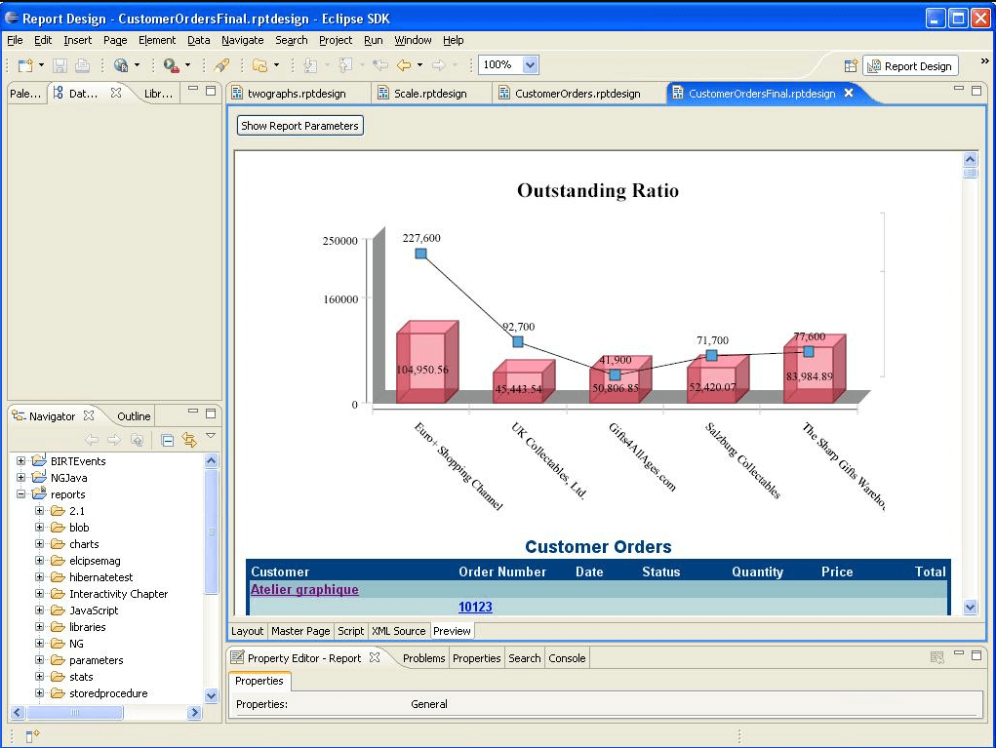

1. **Helical Insight**

[Helical Insight](https://www.helicalinsight.com/) is an open source BI framework that provides e-mail scheduling, visualization, exporting, multi-tenancy, user role management along with an API-driven framework that allows users to add any additional functionality that they may be needed. The Instant BI feature lets people type questions in a Google-like interface and receive the relevant reports and charts.

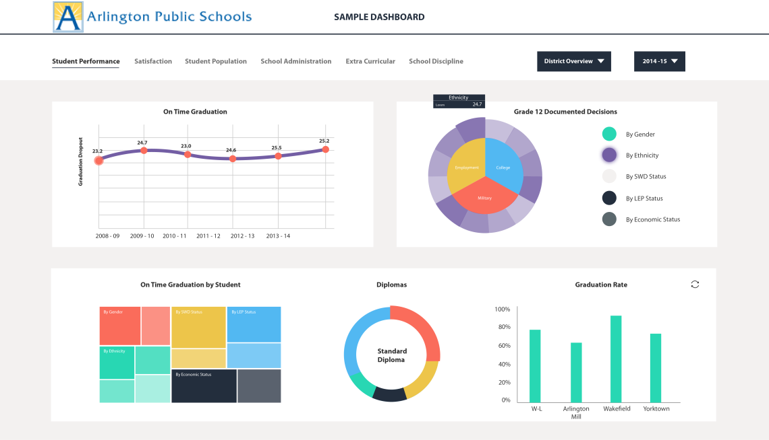

1. **Jedox**

[Jedox](https://www.jedox.com/en/) provides powerful planning and beautiful reporting on every desktop and mobile device. The platform provides a rich, interactive experience with real-time modelling.

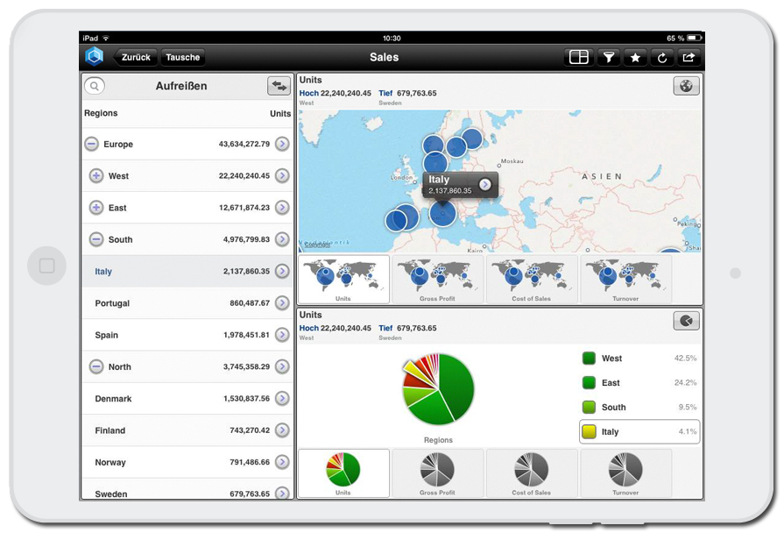

1. [**RapidMiner**](https://rapidminer.com/)

RapidMiner allows data scientists to build a complete analytical workflow in data science and business intelligence projects, allowing them to do data preparation, modeling, and deployment in a single environment.

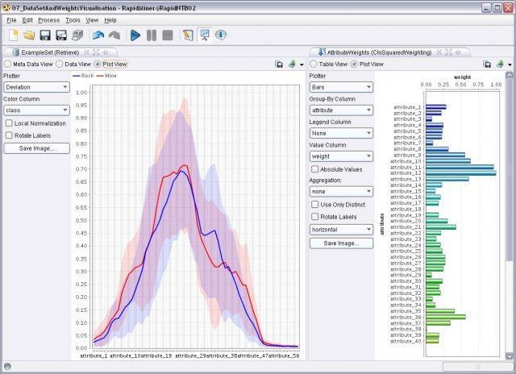

1. **Tableau Public**

[Tableau Public](https://public.tableau.com/) is a free BI software that allows people to create interactive charts and live dashboards and then publish them on the Internet, embed them on a website, or share them on social media. Material can also be customized for display on desktop, tablet, or mobile devices. Tableau also connects to Google Sheets, and data can be auto-refreshed once per day.

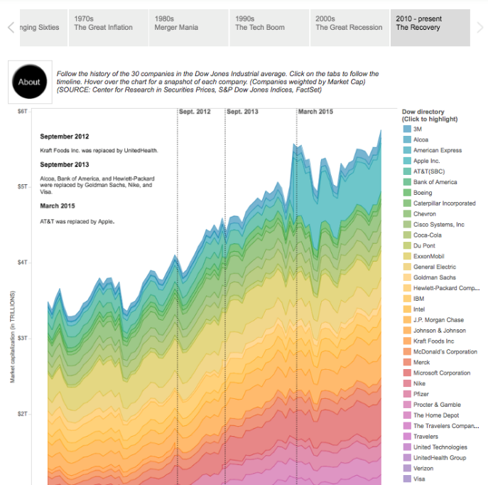

1. **OpenText Magellan**

It is an open source platform that uses artificial intelligence and advanced analytics to optimize business processes and improve decision making – all based on data an organization already has. It is a flexible AL and Analytics platform that combines open source machine learning with advanced analytics, enterprise-grade BI, and capabilities to acquire, merge, manage and analyze Big Data and Big Content stored in an organization.

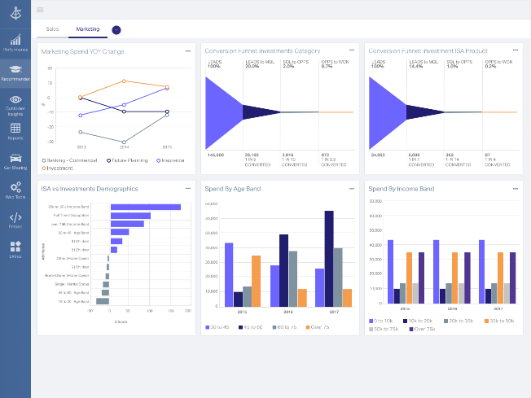

1. **Version Control System using Git**

**Aim**

To use Git for Version Controlling System

**Algorithm**

## **Git an Introduction**

* Git is a version control system which lets users track changes they make to ytheir files over time.
* With Git, users can revert to various states of their files (like a time traveling machine).
* Users can also make a copy of their file, make changes to that copy, and then merge these changes to the original copy.
* **Install the Git**

### **Configure Git**

* run this command on the command line: **git -- version** 🡪 shows the current version installed
* The next thing you'll need to do is to set users username and email address.
* Git will use this information to identify who made specific changes to files.
* To set username, type and execute these commands:
  + **git config --global user.name "YOUR_USERNAME"**
  + **git config --global user.email "YOUR_EMAIL".**
* create a folder on my desktop called
  + **Git and GitHub tutorial.**
  + navigate to your new project's location.
    - **cd desktop**
    - **cd Git and GitHub tutorial**
* Now to initialize the project, simply run
  + **git init** 🡪will tell Git to get ready to start watching the files for every change that occurs.

### **Git project files**

* Create a file called todo.txt.
* The file looks like:

MY TO-DO LIST

1. Write an article.

2. Code.

3. Study books.

4. Attend classes on time.

5. Visit aunt.

6. Apply for remote jobs.

## **How to push a repository to GitHub**

### **Step 1** – **Create a GitHub account -**To be able to use GitHub, will have to create an account first. Can do that on their [website](https://github.com/).

### **Step 2** – **Create a repository** - click on the + symbol on the top right corner of the page then choose "New repository". Give repo a name then scroll down and click on "Create repository".

### **Step 3** – **Add and commit file(s)** - Before "add" and "commit" the files, need to understand the stages of a file being tracked by Git.

#### Committed state

* A file is in the **committed** state when all the changes made to the file have been saved in the local repo.
* Files in the committed stage are files ready to be pushed to the remote repo (on GitHub).

#### Modified state

* A file in the **modified** state has some changes made to it but it's not yet saved.
* This means that the state of the file has been altered from its previous state in the committed state.

#### Staged state

* A file in the **staged** state means it is ready to be committed.
* In this state, all necessary changes have been made so the next step is to move the file to the commit state.

### **How to add files in Git**

* When first initialized the project, the file was not being tracked by Git.
* To do that, use this command

**git add .**  🡪 The period or dot that comes after add means all the files that exist in the repository.

If want to add a specific file, maybe one named about.txt, use

**git add about.txt.**

* Now our file is in the staged state.

**How to commit files in Git**

* The next state for a file after the staged state is the committed state.
* To commit the file, use the command

**git commit -m "first commit"** .

* The first part of the command **git commit** tells Git that all the files staged are ready to be committed so it is time to take a snapshot.
* The second part **-m "first commit"** is the commit message.
* **-m** is shorthand for message while the text inside the parenthesis is the commit message.

### **Step 4** – **Push the repository to GitHub**

* + After create the repo, should be redirected to a page that tells how to create a repo locally or push an existing one.
  + These are the commands:

**git remote add origin “https://github.com/.....”**

**git branch -M main**

**git push -u origin main**

* **Add the changes in the file**

**MY TO-DO LIST**

**1. Write an article.**

**2. Code.**

**3. Study books.**

**4. Attend classes on time.**

**5. Visit aunt.**

**6. Apply for remote jobs.**

**7. Practice code**

* After adding the new task, run the command

**git status**

* + After making changes to the file, it moved to the modified state – but it's not yet staged for commit, so user can't push it to GitHub yet.
  + Git has not taken a final snapshot of this current state as it's only comparing the changes we have made now with the last snapshot.
  + Now going to add (stage) this file and then commit and push it. This is the same as in the last section.
  + We first add the file by using **git add .** which adds all the files in the folder (one file in our case). Then we commit the file by running **git commit -m "added new task"** followed by

**git push -u origin main.**